A THESIS

THE EFFECT OF CONTEXTUAL TEACHING MATERIAL ON
STUDENTS’ READING COMPREHENSION OF THESECOND
GRADE OF MA DDI LIL-BANAT PAREPARE

BY
RAHMATIA ARMAN
REG NUM. 18.1300.005

ENGLISH EDUCATION PROGRAM
TARBIYAH FACULTY
STATE ISLAMIC INSTITUTE
PAREPARE

2023
A THESIS

PAGE OF TITTLE
THE EFFECT OF CONTEXTUAL TEACHING MATERIAL ON
STUDENTS’ READING COMPREHENSION OF THESECOND
GRADE OF MA DDI LIL-BANAT PAREPARE

BY
RAHMATIA ARMAN
REG NUM. 18.1300.005

Submitted to the English Program of Tarbiyah Faculty of State
Islamic Institute of Parepare in Partial Fulfillment of the Requirements
for the Degree of Sarjana Pendidikan (S.Pd.)

ENGLISH EDUCATION PROGRAM
TARBIYAH FACULTY
STATE ISLAMIC INSTITUTE (IAIN)
PAREPARE

2023

ENDORSEMENT OF CONSULTANT COMMISSIONS

The Title of Thesis : The Effect of Contextual Teaching Material on Students’ Reading Comprehension of the Second Grade of MA DDI Lil-Banat Parepare
Name of the Student : Rahmatia Arman
Student Reg. Number : 18.1300.005
Study Program : English Education
Faculty : Tarbiyah
By Virtue of Consultant Degree : The Dean of Tarbiyah Faculty Certificate
No. 2383/2021

Approved by
Consultant Commissions
Consultant : Dr. Zulfah, M.Pd. (...........................)
NIP : 19830420 200801 2 010
Co-Consultant : Drs. Abd. Rauf Ibrahim, M.Si. (...........................)
NIP : 19581212 199403 1 002

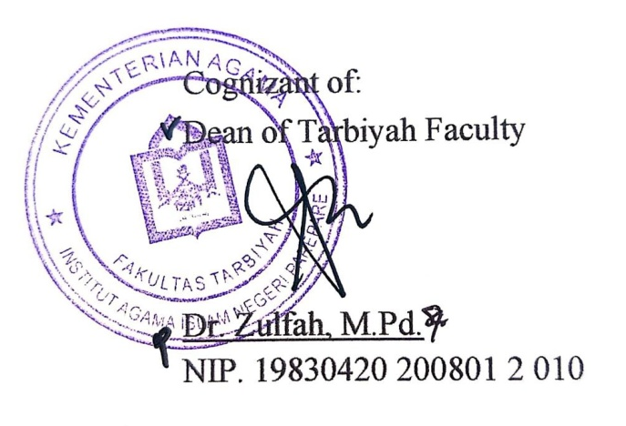

Cognizant of:
Dean of Tarbiyah Faculty

Dr. Zulfah, M.Pd.
NIP. 19830420 200801 2 010

ENDORSEMENT OF EXAMINER COMMISSIONS

The Title of Thesis : The Effect of Contextual Teaching Material on Students’ Reading Comprehension of the Second Grade of MA DDI Lil-Banat Parepare
Name of the Student : Rahmatia Arman
Student Reg. Number : 18.1300.005
Faculty : Tarbiyah
Study Program : English Education
By Virtue of Consultant Degree : The Dean of Tarbiyah Faculty Certificate
No. 2383/2021
Date of Graduation : July 24th, 2023

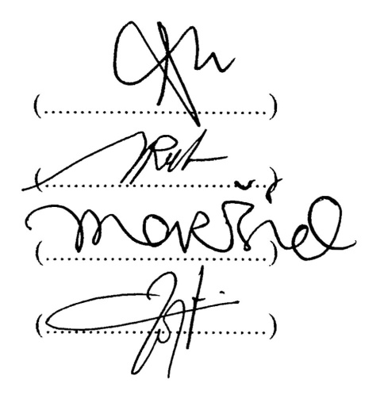
Approved by Examiner Commissions
Dr. Zulfah, M.Pd. (Chairman) (...............................)
Drs. Abd. Rauf Ibrahim, M.Si. (Secretary) (...............................)
Dr. Arqam, M.Pd. (Member) (...............................)
Nurul Hasanah, M.Pd. (Member) (...............................)

Cognizant of:
Dean of Tarbiyah Faculty

Dr. Zulfah, M.Pd.
NIP. 19830420 200801 2 010

ACKNOWLEDGMENTS
بِسْمِ اللّهِ الرَّحْمَنِ الرَّحِيْمِ
اَلْحَمْدُ ِللهِ رَبِّ الْعَالَمِيْنَ وَالصَّلاَةُ وَالسَّلاَمُ عَلَى أَشْرَفِ اْلأَنْبِيَاءِ وَالْمُرْسَلِيْنَ وَعَلَى اَلِهِ وَصَحْبِهِ أَجْمَعِيْنَ أَمَّا بَعْدُ
First of all, the researcher would like to express her profound gratitude to Allah SWT, the Almighty for the health and long life, blessing, mercy and chance given to her to finish writing the thesis. Salam and shalawat are addressed to our Prophet Muhammad SAW, who guided us from the darkness to return in Islam.
The researcher realizes that in writing this thesis, many people help her a long with their valuable suggestion, guidance, inspiration, advices and motivation for the completion of the thesis. Therefore, the researcher would like to express the deepest gratitude to her beloved parents Arman. S and Rahmawati who have given an endless love, advice, support and praying to be success student ever.
Then, the researcher would like to convey to the advisors, Dr. Zulfah, M.Pd., as the first consultant and Drs. Abd. Rauf Ibrahim, M.Si., as the second consultant. The most incredible honor and most profound appreciation dedicated their time to encouragement and excellent advice, magnificent suggestion, and massive support during this research.
The researcher also would like to express the deepest and great thanks to:
- Dr. Hannani, M.Ag., as the Rector of IAIN Parepare who has worked hard to manage education at IAIN Parepare.
- Dr. Zulfah, M.Pd., as the Dean of Tarbiyah Faculty IAIN Parepare, who has arranged a positive education for the students in faculty of Tarbiyah.
- Kalsum, M.Pd., as the Chairman of English Education Program at IAIN Parepare for the fabulous serving to the students.
- All lectures of English Education and Tarbiyah Faculty who have already taught the researcher during her study at IAIN Parepare.
- All the staffs of Tarbiyah Faculty who has worked hard in order to complete the administration for this thesis.
- The English teacher of MA DDI Lil-Banat Parepare Mrs. St. Mashita, S.Pd.I., who has helped researcher a lot.
- All students of the second grade at MA DDI Lil-Banat Parepare for their cooperation and respons in supporting the data.
May Allah SWT always bless them. The researcher realizes that this thesis is still far from being perfect, criticism and suggestion would be acceptable to make it better. Hopefully, this thesis will be useful for all of us and for the development of English teaching learning. Aamiin.
Parepare, February 9th 2023
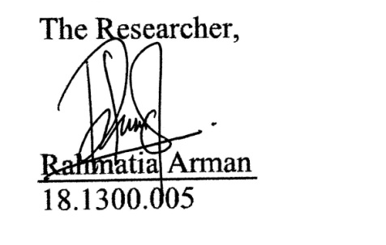
18 Rajab 1444 H
The Researcher,

Rahmatia Arman
18.1300.005

DECLERATION OF THE AUTHENTICITY OF THE THESIS
The researcher who signed the declaration below:
Name : Rahmatia Arman
Student Reg. Number : 18.1300.005
Place and Date of Birth : Parepare, 25 March 2000
Faculty : Tarbiyah
Study Program : English Education
The Title of Thesis : The Effect of Contextual Teaching Material on Students’ Reading Comprehension of The Second Grade of MA DDI Lil-Banat Parepare
Stated this thesis was her own writing and if it can be proved that was copied, duplicated or compiled by any other people, this thesis and the degree that has been gotten would be postponed.

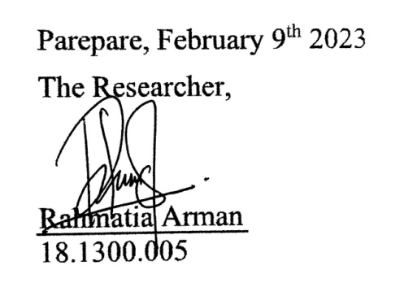
Parepare, February 9th 2023
The Researcher,

Rahmatia Arman
18.1300.005

ABSTRACT
Rahmatia Arman. 2023. The Effect of Contextual Teaching Material on Students’ Reading Comprehension of The Second Grade of MA DDI Lil-Banat Parepare. (Supervised by Zulfah and Abd. Rauf Ibrahim).

This study examined the effect of contextual teaching material on students’ reading comprehension at the second grade of MA DDI Lil-Banat Parepare. It can be seen that the reading comprehension of the students was quite low so the researcher tried to use contextual teaching material in the reading class.
This study used quasi-experimental as a research design with one experimental class and one control class. It used a reading test as an instrumentin the form of multiple choices, by giving students 10 numbers of questions related to the topics given. The population of this research was the second grade students of MA DDI Lil-Banat Parepare which consisting of 38 students. The sample of this research were 38 students of MA DDI Lil-Banat Parepare consisting of XI IPA and IPS class by using total sampling technique. There were three steps in collecting the data, namely pre-test, treatment, and post-test. This study used quantitative analysis such as calculating the rate frequency and percentage of pre-test and post-test, the mean score, standard deviation, and t-test value.
Based on the result of findings, it can be concluded that there was a significant difference score between the experimental class using contextual teaching material and the control class using conventional teaching material. It was proven by the average value obtained in the experimental class was higher than the control class (20 > 7,8). The mean score in the pre-test and post-test of experimental class was 47 > 67, meanwhile the mean score in the pre-test and post-test of control class was 42,8 > 50,6. It was also supported by the t-test value which was higher than the t-table value (1.76 > 1.68). The result of the research proved that the use of contextual teaching material was effective to be used in teaching reading. From the statement above, it can be said that the null hypothesis (H₀) was rejected and the alternative hypothesis (H₁) was accepted. Therefore, it can be concluded that students’ reading comprehension can be improved by using contextual teaching material.

Keywords: Reading comprehension, Contextual teaching material

TABLE OF CONTENTS

COVER i
PAGE OF TITTLE ii
ENDORSEMENT OF CONSULTANT COMMISSIONS iii
ENDORSEMENT OF EXAMINER COMMISSIONS iv
ACKNOWLEDGMENTS v
DECLERATION OF THE AUTHENTICITY OF THE THESIS vii
ABSTRACT viii
TABLE OF CONTENTS viii
LIST OF TABLE viii
LIST OF FIGURE viii
LIST OF APPENDICES viii
CHAPTER I INTRODUCTION 8
A. Background 8
B. Research Question 8
C. Objective of the Research 8
D. Significance of the Research 8
CHAPTER II REVIEW OF LITERATURE 8
A. Previous Related Findings 8
B. Some Pertinent Ideas 8
1. Concept of Contextual Teaching Material 8
2. Concept of Reading Comprehension 8
C. Conceptual Framework 8
D. Hypothesis 8
CHAPTER III METHODOLOGY OF THE RESEARCH 8
A. Research Design 8
B. Location and Duration 8
C. Population dan Sample 8
D. Procedure of Collecting Data 8
E. Variable Operational Definition 8
F. Research Instrument 8
G. Technique of Data Analysis 8
CHAPTER IV FINDING AND DISCUSSION 8
A. Research Finding 8
B. Discussion 8
CHAPTER V CLOSING 8
A. Conclusion 8
B. Suggestion 8
BIBLIOGRAPHY 8
APPENDICES

LIST OF TABLE
Number of Table | The Tittle of Tables | Pages
3.1 | Research design | 27
3.2 | The criteria of the students score classification | 34
4.1 | Scoring reading comprehension of experimental and control class | 38
4.2 | Classification of students’ scores in the pre-test and post-test of experimental class and control class | 39
4.3 | Total pre-test and post-test scores of students in the experimental class and control class | 41
4.4 | The mean score in experimental and control class | 43
4.5 | The normality of pre-test in experimental and control class | 46
4.6 | The normality of post-test in experimental and control class | 47
4.7 | The homogeneity of variances of pre-test in experimental and control class | 48
4.8 | The homogeneity of variances of post-test in experimental and control class | 48
4.9 | The t-test result of post-test score of experimental and control class | 49
4.10 | Indepedent sample test | 49

LIST OF FIGURE
Number of Figure | The Tittle of Figure | Pages
2.1 | Conceptual framework | 25

LIST OF APPENDICES
Number of Appendix | The Tittle of Appendices
1 | Pre-test and post-test answer sheet instrument
2 | Lesson plan
3 | Students’ pre-test and post-test of experimental class
4 | Students’ pre-test and post-test of control class
5 | Students’ pre-test and post-test in experimental and control class
6 | Documentation
7 | Determination of student thesis supervisor
8 | Research permit recommendation
9 | Recommendation letter from Dinas Penanaman Modal dan Pelayanan Terpadu Satu Pintu
10 | Letter of research completing

CHAPTER I

INTRODUCTION

Background
Teaching material is one of the elements that plays an important role in the process of English learning. The success of English learning depends on the effectiveness and efficiency of the teaching materials used. Teaching material is one of the learning tools that contains concepts or materials. According to Pannen and Purwanto, teaching material is material that are systematically arranged and used by teachers and students during the learning process(Pannen & Purwanto, 2001). A similar opinion was also expressed by Majid who stated that teaching material is all types of materials used by teachers or instructors to facilitate teaching and learning activities(Majid, 2011). Moreover, Ruhimat stated that teaching material is basically the contents of the curriculum(Ruhimat, 2011). From the explanation above, it can be concluded that teaching material is all forms of materials that are systematically arranged and designed according to the applicable curriculum to support the learning process.
Teaching material is an element that must be considered by the teacher because it is an alternative that can assist students in achieving learning objectives. In addition, teaching material is considered very important for both students and teachers. As stated by Perwitasari et al. that teachers will struggle to increase the effectiveness of learning and students will struggle to adjust to learning without teaching material, especially if the teacher teaches material that they do not understand at all (Perwitasari et al., 2018). Therefore, the existence of quality teaching material can help students to actively learn independently.
However, the conditions that occur in the field, in English learning, especially in teaching reading, most teachers only use reading material from textbook. Meanwhile, as we know, usually the reading material in the textbook is not contextual or does not relate to the real world situation of students. It was also conveyed by Andi Tenri Ampa et al. that the material used by lecturers was only drawn from textbooks, which occasionally lacked contextual(Ampa et al., 2013).
Based on the result of pre-observation conducted by interviewing English teacher and second grade studentsof MA DDI Lil-Banat Parepare that the difficulties experienced by students in teaching reading were that the majority of students feel lazy, bored, do not even have motivation and interest, and also their minds will float everywherewhen they read the reading material given because the material used is monotonous and not in accordance with their surroundings so that in the end they cannot understand it (Herlina and students, 2022). The same thing was also conveyed by Surbakti et al. in his study that students are still confused in understanding the teaching materials given to them. In addition, students’ learning motivation is also reduced because the textbook’s authors pay less attention to how books are easy to understand and not boring (Surbakti & Tiur Asi Siburian, n.d.). So, it will affect students’ poor reading comprehension.
The teacher's role in the learning process affects the success of learning so that learning objectives can be achieved properly. Therefore, teachers must exercise creativity in developing their own teaching material in addition to using those that the government has already published. In particular, teaching material must be adapted to the needs and characteristics of the students.
In the learning process, teachers should use teaching material that are varied, easy to understand, and close to the students’ learning environment or known as contextual terms. This is in line with what was expressed by Perwitasari et al. that textbooks must present material that is adapted to the conditions and the immediate environment of students in order to provide a meaningful learning experience for students (Perwitasari et al., 2018). By using contextual material as teaching material in the classroom, it can facilitate and improve students' understanding of learning.
The use of contextual teaching material in the teaching and learning process can increase students' motivation and interest in learning so that it will have an impact on improving their learning outcomes. Garin et al. in Flores stressed the importance of using contextual teaching material to help students reach their full learning potential, which is demonstrated by an improvement in their learning outcomes (Flores, 2021). In addition, contextual teaching material aims to facilitate students in teaching reading because when reading the text material students no longer need to imagine and guess at the contents of the reading because the material provided is related to real situations experienced by students. Therefore, contextual teaching material is considered as an effective teaching material used in teaching reading.
Based on the background above, the researcher is interested in conducting research with the title: "The effect of contextual teaching material on students' reading comprehension of the second grade of MA DDI Lil-Banat Parepare".

Research Question
Considering the background above, the researcher formulates the research question as follows: “Is contextual teaching material effective to improve the students’ reading comprehension at the second grade of MA DDI Lil-Banat Parepare?”.

Objective of the Research
The objective of this research is to examine the effect of contextual teaching material on students’ reading comprehension of the second grade of MA DDI Lil-Banat Parepare.

Significance of the Research
This research is expected to give contribute both theoritical and practical aspects as follows:
- Theoritical Significance
It is expected to give information and knowledge in English learning especially in teaching reading for Senior High School.
- Practical Significance
- For the students, the result of this research is expected to help them to understand reading text easier so they can learn English very well.
- For the teachers, the result of this research is expected to encourage them to make their teaching and learning process more effective by using contextual teaching material in teaching reading and as a consideration in choosing teaching material.
- For other researchers, it is expected that this research will be beneficial for other researchers as a reference and increasing knowledge about contextual teaching material.

CHAPTER II

REVIEW OF LITERATURE
In this chapter, the researcher intends to present previous related findings, some pertinent ideas, conceptual framework, and hypothesis.

Previous Related Findings
The first previous study was conducted to develop the effectiveness of contextual material for teaching English at Madrasah Aliyah. The ADDIE model was applied as the design in this development research study. Two books—one for teacher and the other for student—with the heading “English for Us” made up as its final result. The participants in this study were all students of grade X. 87 people who were chosen as samples in this study were selected by using the purposive technique. Data was collected through interviews, questionnaires, and surveys. Both qualitative and quantitative techniques were used for the data analysis. The student's book had an average score of 84,63 whereas the teacher's book had a practicality score of 82,54. Pre-test effectiveness of a product was 68,00, while post-test effectiveness was 75,44. Therefore, it can be said that the contextual material for teaching English at Madrasah Aliyah was effective (Mukhaiyar et al., 2018).
The second previous study was conducted to develop teaching materials on English speaking skill that are suitable for primary English teachers candidates’ demands at the Teacher Training and Education Faculty of Muhammadiyah University of Tangerang. Research and development study, also known as R and D cycle, was employed in this study. Observation, interviews, questionnaires, and product tests employed as the instrument. The findings of this study showed candidates for primary English teachers were given 12 chapters of speaking teaching material based on a contextual approach. The speaking training materials were found to be effective, according to the effectiveness test results (Puspita & Rosnaningsih, 2020).
The third previous study was conducted to develop the contextual learning materials for speaking subject. Three aspects—psychological, pedagogical, and methodological—were used to evaluate the validity of the contextual learning materials developed. In this study, a questionnaire was used to collect data from the experts and then examined it both a quantitatively and qualitatively. In accordance with the findings, contextual learning materials that matched the criteria for psychological, pedagogical, and methodological aspects were highly valid (93,28%).As a result, the stages of the instructional design were appropriate for creating the contextual learning materials for English speaking skills (Ampa et al., 2013).
The fourth previous study was conducted to solve speaking problems of students in an EFL class using contextual internet-based instructional materials. This study used Classroom Action Research design in an English Education Department speaking class at a University in Indonesia. There were two cycles of this study. Each cycle included planning, implementation, observation and reflection. The success criterion required that 80% of the students achieve a speaking score of 75. Less than 80% of students met the requirement according to cycle 1 data, so cycle 2's modified plan was put into action. Cycle 2 was ended since the results showed that more than 80% of the students received score of 75 or higher. The stages for implementing teaching integrated reading and speaking in EFL teaching and learning (TIRS) were proposed, and the design and development of the instructional materials were also examined (Manurung, 2015).
The fifth previous study was conducted to examine the effect of contextual visual aids on Iranian high school students' reading comprehension. A quasi-experimental study with 96 female intermediate-level EFL students as participants was created. A homogenety test was used to select these participants from among 140 students. The chosen participants were divided into four groups: one control group, three experimental groups (pre-thematic, thematic, and post-thematic). The participants performed the pre-test, treatment, and post-test process. Three tests were used to get the data: a PET test, a pre-test, and a post-test of reading comprehension. The results showed that contextual visual aids had a statistically significant effect on the reading comprehension of Iranian high school students. The results of the study also showed that pre-thematic visual aids had the highest effect on high school students' reading comprehension among contextual visual aids.This was followed by thematic visual aids which had a modarate effect on this procces.The post-thematic visual aids, however, have a slightly significant effect on high school students' reading comprehension(Majidi & Aydinlu, 2016).
Then, the research that the researcher did was different from the five previous studies above. The difference between this study and the five previous studies above lies in the type of research used. In this study, the researcher used a quasi-experimental design, while the research conducted by Mukhaiyar et al., Puspita and Asih, Ampa et al. used Research and Development study and the research design conducted by Manurung is a classroom action research (CAR) design. Besides that, the other difference is that the research conducted by Mukhaiyar et al. focused on developing English teaching materials, Puspita and Asih, and Ampa et al. focused on developing teaching materials for teaching speaking skills, Manurung focused on using reading contextual internet-based instructional materials to improve speaking skill, and Majidi and Aydinlu focused on the effect of contextual visual aids on students’ reading comprehension. Meanwhile, this research focused on the effect of contextual teaching materials on students’ reading comprehension.

Some Pertinent Ideas

Concept of Contextual Teaching Material
- Contextual Teaching and Learning
The word contextual comes from English, it means“relating to the context” or “in context”. Context here means circumstances, situations and events. In general, the word contextual has the following meanings:
- relating to, relevant, there is a direct relationship or connection, according to the context; and
- bring meaning, meaning and importance (meaningful) (Ningrum, 2009).
Contextual in learning or better known as Contextual Teaching and Learning is a learning concept that enables teachers to relate the content of the subject matter being taught to the students' real world situations(Mudlofir & Rusydiyah, 2016). In other words, students might be encouraged by CTL to connect their information to how it can be used in their daily life. Thus, it is anticipated that students will find learning results to be more meaningful.
- Teaching Material
The use of instructional material is one of the elements that can impact how well a lesson is taught and how well a student learns. Due to their ability to aid both teachers and students in learning new languages, teaching materials are crucial to the teaching and learning process. All types of materials created with the intention of facilitating learning are referred to as teaching materials.
Amri in Utami et al. stated that teaching material both in written and unwritten form is all materialsused in classrooms by teachers to conduct teaching and learning process. Majid further explained that there are two definitions of teaching material: 1) Teaching materials include all knowledge, resources, and texts that instructors or teachers require to organize lessons. 2) teaching material is all written and unwritten material used by teachers or instructors to carry out teaching and learning activities in class(Utami et al., 2018).
According to Prastowo in Mukhaiyar et al. teaching material is any information, tools, or texts that are organized systematically, showcasing all types of competency that students can master, and used to aid in the learning process with the intention of organizing and conducting exams(Mukhaiyar et al., 2018). From some of those explanations, it can be concluded that teaching material includes any written or unwritten information, tools, or texts that are organized systematically to aid teachers in the classroom learning process.
The following are some assumptions made by Gagne, Briggs, and Wager in Santosa et al. regarding the significance of teaching material in particular and learning planning in general:
- supporting students individually
- providing space for short-term and long-term learning
- designing teaching materials in a systematic way that has a significant impact on the individual human resource development
- streamlining the management of the teaching-learning process with a systematic approach, and
- streamlining the learning process because they are created based on the understanding of how people learn (Santosa et al., 2014).
Ornstein and Hunkins stated that selecting and employing teaching materials is essentially the same as selecting the learning methods and media to be employed(Onrstein & Hunkins, 2009). Learning activity will not result in anything if there are no teaching materials. There aren't any best or worst teaching resources; everything depends on how well the approaches are suited to the students' needs.Akker in Mukhaiyar et al. stated that an effective teaching materials must be in accordance with the characteristics, settings, and needs of students(Mukhaiyar et al., 2018). This is in line with what was conveyed by Diaz-Rico which stated that the selection of English teaching material must be in accordance with the learning objectives(Diaz-Rico, 2008). In addition, a good teaching material is good if it has three criteria which are valid, practical, and effective.
According to the Educational Technology Development Agency in Mukhaiyar et al. teaching materials serve as a) guidelines for teachers, who will lead all of their activities in the teaching and learning process, as well as a substance of competences that must be taught, b) guidelines for students, who will direct all of their activities in the teaching and learning process, as well as c) a tool for measuring the accomplishment of learning outcomes(Mukhaiyar et al., 2018).
- Contextual Teaching Material
According toAmpa et al., contextual teaching material is materials that allow students to process new information or knowledge according to their own frames of reference(Ampa et al., 2013).From that explanation, it can be concluded that contextual teaching material is materials that enable students to understand something that has just been obtained in the context of their own personal experiences.
Monteiro and Pereira in their study stated that the use of contextualized instructional materials made it easier and more motivating for students to acquire new content by connecting it to their daily lives. This is to aid in the learning process, particularly so that students may master and sharpen their creative writing abilities when producing stories for children. This instructional material not only supports students but also helps teachers in deepening their understanding of children's story writing abilities(Monteiro & Pereira, 2022).Additionally, it is claimed in their study that using instructional material to create stories based on contextual children is more effective in enhancing students' learning outcomes and creativity in children's story writing abilities. Based on that explanation, it can be concluded that using contextual teaching material can help students learn more effectively by motivating them so that their learning outcomes increase. In addition, contextual teaching material is also useful for teachers because they can expand their knowledge about teaching material.
The purpose of instructional materials is to inspire and unleash the full potential of the students. For students to be successful in their studies, good teaching materials must enable and provide enough room for them to practice using the language as well as materials that are contextual or relevant to their circumstances, such as their environment, experiences, or past knowledge(Santosa et al., 2014). It is believed that there are more chances for learning to be transferred when students are taught in a context that corresponds to the immediate circumstance in which they will use the material.
The reading material given must be carefully arranged in order to facilitate students’ comprehension. Additionally, the provided reading materials must be costumized to the needs and the interest of the students. Therefore, the teaching material used in this study will be contextual teaching material. Contextual material is used since it is believed that they are considered to increase students’ motivation and interest in reading. This occurs because reading materials that are suited for the students’ learning environment are included in contextual teaching material. As a result, it is believed that contextual teaching materials are considered to be able to facilitate and improve students' reading comprehension. Students can understand the reading material since it is relatable to them, so it can prevents their minds from wandering while they read it.
- Contextual Teaching Material In Teaching Reading Comprehension
Contextual material in teaching reading is a type of text used in the learning process where the content of the text is something that is close to or in accordance with students. So, the selection of the text is adjusted to the conditions and learning environment of students. For example, there are two types of text given to students, namely "The history of United States" and "The effect of TikTok". From the two types of texts, the most relates to students is the second reading because they feel, use, and even know very well what TikTok is. So, when students read it their minds will not float and they don't even need to imagine and guess at the contents of the reading. The example of contextual material is as follows:
TONRANGENG RIVER SIDE
Tonrangeng River Side is one of the most famous places in Parepare. It is a flyover that connects the Sumpang Bridge with the Type B+ Hospital which is decorated with sparkling colorful lights at night. Located in Lumpue, West Bacukiki, Parepare City.
This flyover was built over the Karajae River with a width of 6 meters and a length of 125 meters. Both sides of the road are provided with sidewalks each approximately 1.5 meters wide as access for pedestrians. Meanwhile, in the middle of it, which is about 12 meters wide, a garden is made to make it look prettier. Along the flyover is decorated with colorful lights that will look very beautiful at night in green, white and orange.
In the southern side of Torangeng River Side, there is a green open space filled with lots of shady trees so it feels cool and fresh. While in the northern side there is a traditional culinary tour with a floating restaurant. There are also marine tours that take visitors to see the beauty of the Karajae River by using the boats provided.

Concept of Reading Comprehension
- Definition of Reading
Reading is one of the most important academic language skills in English besides other skills. It is an aspect of language skills that is crucial to everyone’s daily existence. People will gain enjoyment, more knowledge, and variety of information by reading.
Daiek stated that reading is an active process that depends on the author's ability to convey meaning via the use of words and the reader's ability to infer meaning from those words(Daiek, 2004). The readers must continually make connections between the information they already know and the writer’s words in order to read effectively.
According to Tarigan in Kholiq and Luthfiyati, reading is a method used by readers to comprehend the writer's message as it is expressed in words or other written language(Kholiq & Luthfiyati, 2018).A difficult process that allows the meaning of each word to be understood and the set of words to be quickly understood. If it isn't met, the reader won't be able to notice or understand the explicit and implicit signals, and the reading process won't be carried out successfully.Simply, reading can be considered a method of verbal communication between the author and the reader.
Reading was defined by Aebersold and Field in Rahayu as an activity in which individuals examine written symbols in a text and give them meaning. In addition, Nunan also said reading is the process of deciphering written symbols, starting with a smaller unit (individual letters) and working up to a bigger one (words, clauses, and sentences)(Rahayu, 2015).
From several explanations above, it can be concluded that reading is an activity carried out by the reader to get the message conveyed by the writer through written symbols in a text, starting from smaller unit to larger one.
- Purpose of Reading
People read things for various purposes. The reader's interpretation of what they have read is usually its main goal. Reading seeks to make connections between what the reader already knows and the concepts in the text. To link the ideas, readers must be knowledgeable about the material they are reading.Besides, finding out what the writer’s intended message in a text is also one of the readers’ most important tasks.
Anderson in Dalman stated that there are seven purposes of reading, they are:
- Reading for specifics and facts: reading to learn what the story's protagonist does.
- Reading for primary ideas: reading to understand the issue.
- Reading for organization and sequence: reading to understand each section of the story.
- Reading for inference: reading to understand what the author intended by their story.
- Reading for categorization: reading to discover peculiar things.
- Reading for evaluation: reading to determine the significance of the narrative.
- Reading for comparison or contrast: reading to contrast the reader's way of life with the way the story is written(Dalman, 2013).
While, according to Grabe and Stoller, the purposes of reading consist of:
- Reading to search for simple information
- Reading to skim quickly
- Reading to learn from text
- Reading to integrate information
- Reading to write
- Reading to critique texts
- Reading for general comprehension(Grabe & Stoller, 2002).
Based on the description above, in essence understanding a text and gaining new knowledge are the goal of reading. Every reader has a different reason for reading, depending on their needs, but the goal is the same, which is to comprehend what is being read. In addition, the aim of the reader influences how he reads a paragraph and which comprehension skills he employs. In other words, it is unavoidable to say that the reader's motivation will affect how he reads a text.
- Types of Reading
Generally, reading is divided into two categories, they are reading aloud for mechanical skills and silent readingfor comprehension skills(Alfin & Wahyuni, 2008).
- Reading Aloud
Reading aloud is a reading exercise where sound symbols are voiced. In particular, suprasegmental aspects like tone, intonation, stress, pronunciation, stopping, and so on, are important to master when reading aloud.
- Silent Reading
Silent reading is a reading activity in which sound symbols are read without voice. Students have the chance to fully comprehend the texts they read through this kind of reading.Therefore, the most appropriate to use for comprehension skills is silent reading. Then, type of silent reading include:(Riski, 2019).
- Extensive Reading
When reading extensively, a variety of reading materials are used, and the reading activity is done quickly and in a large amount of volume. Three types of extensive reading exist: survey reading, skimming, and shallow reading.
- Intensive Reading
Reading that is done carefully and thoroughly with the intention of fully comprehending is referred to as intensive reading. Only one or a few options from already-existing materials are used as reading material. This kind of reading is an attempt to develop and improve critical reading abilities. Intensive reading is divided into two: 1) reading the content review, which entails careful reading, reading comprehension, critical reading, and reading ideas. 2) reading language studies includes reading language and reading literature.
Then, the type of reading that will be discussed in this study is reading comprehension.The researcher will examine students' reading comprehension, which aims to understand the content of the texts they read. Students are expected to be able to answer questions posed by the teacher related to the reading.
In addition, there are some reading strategies that will be used by the researcher. The reading strategy to be used are previewing (activating prior knowledge), predicting, identifying the main idea, and question guide.
- Definition of Reading Comprehension
The majority of students simply read and move on without understanding the main idea of the text they have read. Students who can apply reading comprehension, on the other hand, tend to be more advanced and develop into intelligent students of their class because they can gain knowledge, understanding, and a lot of information from reading. Understanding everything they read will help them develop more critical thinking skills and broaden their knowledge(Damanik & Herman, 2021).
Reading is an activity that aims to understand the content of reading text through word-by-word or sentence-by-sentence recognition activities. Reading also can be said as a process of finding information contained in the reading text in order to gain a comprehension of the text. Satriani stated that understanding what we read and relating the concepts to what we already know are also parts of comprehension, which goes beyond just word recognition and understanding. Comprehension requires an active thought. It means that to comprehend a text, one must understand its words, relate them to its core idea, and retain its context(Satriani, 2018).
Grabe and Stoller stated that reading comprehension is the ability of someone to comprehend or to derive information from a text(Grabe & Stoller, 2002). Vaughn cited in Satriani define reading comprehension as the ability to understand a text after reading it. Furthermore, Woolley stated that reading comprehension is interpreting text to derive meaning. Instead of trying to deduce the meaning of individual words or sentences, the objective is to comprehend what is being described in the text as a whole(Satriani, 2018).
From several explanations above, it can be concluded that reading comprehension is one’s ability to gain a comprehension of what is read. In addition, the ability for drawing inferences is one of the characteristics and skills that affect a person's ability to comprehend the text.
- Levels of Reading Comprehension
- Literal Comprehension
Literal comprehension is the ability to comprehend information that is clearly expressed in a text. Literal comprehension is oriented on the understanding level which the answers (words or phrases) are written in the text. This level is the lowest level of comprehension.
- Interpretative or Inferential Comprehension
Inferential comprehension is the ability to comprehend information expressed indirectly in a text. Inferential comprehension is oriented to the answers that are not explicitly stated in the text.
- Critical Comprehension
Critical comprehension is the ability to evaluate text material. This level is defined as the ability to read comprehension at the comparison level. Critical comprehension is oriented on correct or incorrect answers when two things are being compared, the use of words or phrases, and the quality of words used in reading.
- Creative Comprehension
Creative comprehension is the ability to convey, in accordance with one's own and others' standards, aesthetic and emotional reactions to texts. The ability to read while putting one's creativity to the test is known as the level of creative comprehension. Creative comprehension is oriented towards answers to complete words, phrases, clauses, sentences, or further topics from the text read(Kholiq & Luthfiyati, 2018).
- Indicator of Reading Comprehension
One of the key components of reading activities is comprehension because, in essence, reading skills can be improved by comprehending a text and for the achievement of specific objectives. Thus, the capacity to comprehend written material serves as the definition of reading comprehension.
Therefore, students are expected not only to read but also to be able to understand the reading. Students can understand a reading if they can get information, messages and meanings contained in a reading. In addition, they can retell the essence of the reading and provide feedback about the contents of the reading.
Generally, indicators in reading comprehension skill consist of the ability to capture the content of the reading, the ability to summarize the reading, the ability to answer questions based on the content of the reading, and the ability to retell the content of the reading.
In line with that, Somadayo in Sari et al. explained that a person can be said to understand reading well if he possesses the following abilities: 1) the ability to understand the words and expressions used by the writer; 2) the ability to understand both explicit and implied meanings; and 3) the ability to draw conclusions(Sari et al., 2018).
Meanwhile, Alan Davies and Widdowson in Lestari stated that indicators of reading comprehension ability consist of: 1) direct references, which is detailed in the ability to understand meanings, words, terms, expressions; the ability to capture information in sentences, and the ability to explain terms; 2) inferences, which is detailed in the ability to find the nature of the relationship of an idea and the ability to capture the contents of the reading, both implied and expressed; 3) conjecture, which is detailed in the ability to guess the message contained in the reading and the ability to relate the text to the communication situation; 4) assessment, which is detailed in the ability to assess the text, the ability to assess the accuracy of reading organization, and the ability to assess the accuracy of information disclosure(Lestari, 2019).

Conceptual Framework

Teaching Reading

Conventional Teaching Material

Contextual Teaching Material

Students’ Reading
Comprehension

Each student has a different level of reading comprehension. In this study, the researcher will examine the use of contextual teaching material to improve students’ reading comprehension. The researcher will use contextual teaching material in the experimental class in teaching and learning process and the control class will be given teaching material from textbook as usual.
Reading comprehension can be improved through contextual teaching material by providing appropriate reading material for students. In this case, students will be given a contextual reading material and they are asked to read it carefully and thoroughly. After that, they are then asked to answer the questions that have been provided to measure the extent to which students’ understanding of the text.

Hypothesis
To give a clear direction to a conclusion to be drawn, it is necessary to formulate a research hypothesis. Based on the conceptual framework above, the hypothesis is formulated as follows:
    - Null Hypothesis (H_{o})
There is no significant difference between score of control class and experimental class.
    - Alternatif Hypothesis (H_{a})
There is a significant difference between score of control class and experimental class.

CHAPTER III

METHODOLOGY OF THE RESEARCH

Research Design
In this study, the researcher used quantitative experimental design as a research design. The form of research used is quasi-experimental design by using pre-test and post-test design, and used two classes namely experimental and control class. The design is presented as follows:
Table 3.1 Research design
Group/Class | Pre-test | Treatment | Post-test
E | T1 | X | T2
C | T1 |  | T2
Where:
E : Experiment Group/Class
C : Control Group/Class
T1 : Pre-Test
X : Treatment
T2 : Post-Test

Location and Duration
This research was conducted at MA DDI Lil-Banat Parepare, which is located on Jl. Abu Bakar Lambogo No.53 Kel. Ujung Lare, Kec. Soreang, Kota Parepare. It is located in the DDI Lil-Banat Parepare boarding school complex. The headmaster of this school named Herfina, S.Pd.I. There are 36 teachers in this school, 12 of them are civil servants and the others are not civil servants. This research was conducted in the second or eleventh grade. The second grade English teacher at this school named St. Mashita, S.Pd.I. Then, the research activity was carried out in approximately 1 month.

Population dan Sample
- Population
The population of this study was the entiresecond grade students of MA DDI Lil-Banat Parepare. There were two classes in the second grade that was consist of 38 students. So, the number of population in this study was38students.
- Sample
In this study, the researcher used total sampling technique because there are only two classes in the second grade of MA DDI Lil-Banat Parepare namely XI IPA with 18 students and XI IPS with 20 students, so the samples of this study consisted of 38 students. One of those samples asexperimental class and the other as control class.

Procedure of Collecting Data
- Pre-test
The first step that the researcher did before doing treatment wasprovided a pre-test with the aim of knowing the level of reading comprehension of students. The form of the test that was given is in the form of an individual reading test, by answering questions related to the reading text.
- Treatment
After the pre-test was done, the researcher provided treatment using contextual teaching material to improve students' reading comprehension in experimental class and conventional teaching material in control class.
- The first meeting
- The researcher greeted the students and pray together.
- The researcher checked the students’ attendance and continues by warming up.
- The researcher gave motivation regarding the benefits of learning English before delivering the material.
- The researcher provided material about descriptive text and asked students to identify it together. Then, students were given the opportunity to ask questions if something is not understood.
- The researcher distributed papers containing contextual descriptive text about “Tonrangeng River Side” and did a brainstorming by activiting students’ prior knowledgeby asking what they already know about the topic.
- The researcher gave students a few minutes to read and understand the text.Then, the researcher asked the students to answer the questions related to the reading text.
- The last step, the researcher and students checked the correct answers together and conclude the learning.
- The second meeting
- The researcher greeted the students and pray together.
- The researcher checked the students’ attendance and continues by warming up.
- The researcher gave motivation regarding the benefits of learning English before delivering the material.
- The researcher provided material about descriptive text and asked students to identify it together. Then, students were given the opportunity to ask questions if something is not understood.
- The researcher distributed papers containing contextual descriptive text about “Cempae Pavilion” and did a brainstorming by activiting students’ prior knowledgeby asking what they already know about the topic.
- The researcher gave students a few minutes to read and understand the text.Then, the researcher asked the students to answer the questions related to the reading text.
- The last step, the researcher and students checked the correct answers together and conclude the learning.
- The third meeting
- The researcher greeted the students and pray together.
- The researcher checked the students’ attendance and continues by warming up.
- The researcher gave motivation regarding the benefits of learning English before delivering the material.
- The researcher provided material about descriptive text and asked students to identify it together. Then, students were given the opportunity to ask questions if something is not understood.
- The researcher distributed papers containing contextual descriptive text about “Lumpue Beach” and did a brainstorming by activiting students’ prior knowledgeby asking what they already know about the topic.
- The researcher gave students a few minutes to read and understand the text.Then, the researcher asked the students to answer the questions related to the reading text.
- The last step, the researcher and students checked the correct answers together and conclude the learning.
- The fourth meeting
- The researcher greeted the students and pray together.
- The researcher checked the students’ attendance and continues by warming up.
- The researcher gave motivation regarding the benefits of learning English before delivering the material.
- The researcher provided material about descriptive text and asked students to identify it together. Then, students were given the opportunity to ask questions if something is not understood.
- The researcher distributed papers containing contextual descriptive text about “Paputo Beach” and did a brainstorming by activiting students’ prior knowledgeby asking what they already know about the topic.
- The researcher gave students a few minutes to read and understand the text.Then, the researcher asked the students to answer the questions related to the reading text.
- The last step, the researcher and students checked the correct answers together and conclude the learning.
- Post-test
After the treatment was done, the researcher provided a post-test to measure the level of reading comprehension of students after the treatment is applied. The form of the test given was the same as the test before treatment was given. It aimed to find out whether contextual teaching material was really effective to use in English learning, especially reading comprehension.

Variable Operational Definition
- The researcher used material that are appropriate to the students’ circumstances or called contextual teaching material.
- The type of reading that was discussed in this study is reading comprehension which is part of intensive reading. Level of reading comprehension that was studied is literal and interpretative comprehension.

Research Instrument
Instrument is something used to collect data. In this study, the researcher useda reading test as the instrument to collect data. The reading test consisted of 10 items of multiple choice that was applied in pre-test and post-test to measure the students’ reading comprehension.

Technique of Data Analysis
  - Manually Analysis
The data that has been obtained from pre-test and post-test was then analyzed using the following procedures:
    - Scoring the students’ answer:(Wardani & Wihardit, 2008)
Score = $\frac{Students'correctanswers}{Totalnumberofitems}$ x 100
- Classifying the score of the students’ into five levels as follows:(Arikunto, 2005).

Table 3.2The criteria of the students score classification
No. | Classification | Score
1 | Excellent | 86 - 100
2 | Good | 71 - 85
3 | Fair | 56 - 70
4 | Poor | 41 - 55
5 | Very Poor | ≤ 40
- Calculating the rate percentage of the students’ score:
P = $\frac{F}{N}$ x 100%
Where: P = percentage
F = frequency
N = total number of the sample.(Gay, 1981)
- Calculating the mean score of the students:
$\overline{X}$ = $\frac{\sum{x}}{N}$
Where: $\overline{X}$ = mean score
$\sum{x}$ = the sum of all score
N = total number of students.(Gay, 1981)
- Calculate standard deviation uses the following formula:
SD =$\sqrt{\frac{SS}{N-1}}$
Where:
SS= $\sum{x^{2}-\frac{{\left(\sum{x}\right)}^{2}}{N}}$
Where: SD = standard deviation
SS = sum of square
$\sum{x^{2}}$ = the sum of score
${\left(\sum{x}\right)}^{2}$ = the square of the sum of score
N = total number of students.
- Find out the significant difference between the pre-test and post-test scores using the formula below:
t – test= $\frac{{\overline{X}}_{1}-{\overline{X}}_{2}}{\sqrt{\left(\frac{{SS}_{1} + {SS}_{2}}{n_{1}+ n_{2}-2}\right)\left(\frac{1}{n_{1}} + \frac{1}{n_{2}}\right)}}$
Where: t - test = test of significance
${\overline{X}}_{1}$ = mean score of experimental group
${\overline{X}}_{2}$ = mean score of control group
SS₁ = the sum of square of experimental group
SS₂ = the sum of square of control group
n₁ = total number of students of experimental group
n₂ = total number of students of control group(Gay, 1981).
After the t-test value is obtained, then determined the degrees of freedom (df) by adding total number of students of both groups and then subtracting 2. Then, the result of dfare compared with the t-table. A study is said to be successful if the result of the t-test exceed the result of the comparison between dfand t-table.
  - SPSS Analysis
    - Normality Test
This test is done to find out whether the data obtained from the sample has a normal distribution or not. In this study, the normality test will be carried out by using the Liliefors test. After getting 𝐿₀, it will be compared to𝐿_{t} (0,05), the characteristic of Liliefors test is:
- If L₀<L_{t} = data is normally distributed
- If L₀>L_{t} = data is not normally distributed
    - Homogeneity Test
This test is performed to determine whether the sample is homogeneous or not. Homogeneity test that will be conducted in this study is the Levene test. After getting the 𝐹₀, it will be compared to 𝐹_{t}(0,05), the characteristic of Levene test is:
- If F₀<F_{t} = data is homogeneous
- If F₀>F_{t} = data is heterogeneous
    - T-test
This test id conducted to find out whether there is a significant difference between students’reading comprehension in the experimental class and students' reading comprehension in the control class. The characteristics is:
- If t-test <t-table = H₀ accepted
- If t-test >t-table = H₁ accepted

CHAPTER IV

FINDING AND DISCUSSION
This chapter discussed about how to analyze the data, find and discuss the results of data analysis which included descriptions and results of data processing obtained through research. In addition, there is a proces of testing the hypothesis including an explanation of the improvement in students’ reading comprehension after applying the contextual teaching material.

Research Finding
In this section, the researcher collected data from the results of teaching reading comprehension in two classes using test instruments in the pre-test and post-test. The data obtained from the instrument described as follows.
    - Students’ Score
Table 4.1 Scoring reading comprehension of experimental and control class

In the scoring table above, it can be explained in the experimental class there were results from the students’ pre-test and post-test. In the pre-test score, students got a maximum score of 80 in the good category, a minimum score of 20 in the very poor category, the mean score of 47 in the poor category, the median score of 45 in the poor category and the mode score of 40 in the very poor category. Furthermore, in the post-test score, students got a maximum score of 90 in the excellent category, a minimum score of 30 in the very poor category, the mean score of 67 in the fair category, the median score of 65 in the fair category and the mode score of 50 in the poor category.
In the control class, it can be explained that the pre-test results of students with a maximum score of 70 in the fair category, a minimum score of 10 in the very poor category, the mean score of 43 in the poor category, the median score of 50 in the poor category, and the mode score of 50 in the poor category. Meanwhile, in the post-test post-test score, there were a maximum score of 80 in the good category, a minimum score of 20 in the very poor category, the mean score of 51 in the poor category, the median score of 50 in the poor category, and the mode score of 60 in the fair category.
    - Scoring Classification
Table 4.2Classification of students’ scores in the pre-test and post-test
of experimental class and control class
No | Classification | Score | Class/Group
 |  |  | Experimental Class |  |  |  | Control Class
 |  |  | Pre-test |  | Post-test |  | Pre-test |  | Post-test
 |  |  | F | % | F | % | F | % | F | %
1 | Excellent | 86 - 100 | - | - | 5 | 25 | - | - | - | -
2 | Good | 71 - 85 | 1 | 5 | 3 | 15 | - | - | 2 | 11,1
3 | Fair | 56 - 70 | 5 | 25 | 5 | 25 | 3 | 16,7 | 6 | 33,3
4 | Poor | 41 - 55 | 4 | 20 | 6 | 30 | 8 | 44,4 | 3 | 16,7
5 | Very Poor | ≤ 40 | 10 | 50 | 1 | 5 | 7 | 38,9 | 7 | 38,9
Total |  |  | 20 | 100 | 20 | 100 | 18 | 100 | 18 | 100
In the table of experimental class above, it can be seen that the pre-test data showed that some of students got a very poor category with a frequency of 10 (50%) out of 20 students which has difficulty in comprehending the content of a text. Moreover, there were 4 (20%) students who got a poor category, 5 (25%) students who got a fair category, and there was only 1 (5%) student who got a good category. That way, it can be said that before the treatment was given, the students’ reading comprehension was still very low so that most of them were included in the very poor and poor categories. Therefore, the researcher provided treatment by applying contextual teaching material to improve students’ reading comprehension in class.
In the post-test section, the researcher has given treatment by applying contextual teaching material and it was proven that this material can improve students’ reading comprehension, of which there were 5 (25%) students who got an excellent category, 3 (15%) students who got a good category, 5 (25%) students who got a fair category, 6 (30%) students who got a poor category, and 1 (5%) student who got a very poor category. From the data obtained in the post-test, it can be seen that the previous classification of very poor category reduced from 10 (50%) to 1 (5%), meanwhile the previous classification of good category increased from 1 (5%) to 3 (15%), and the classification of excellent category increased to 5 (25%) whereas in the previous pre-test there were no students got an excellent category. Therefore, the use of contextual teaching material can be said to be good used in teaching reading in class.
Meanwhile, the pre-test data of control class showed that most students got poor category with a frequency of 8 (44.4%) and 7 (38.9%) students got very poor category out of 18 students in control class. Besides, there were only 3 (16.7%) students who got fair category. Thus, the reading comprehension of students in this class can be said to be very lowbecause more than 80% of the 18 students got the poor and very poor categories.
In the post-test section, the data showed that students’ score had an increase after being given treatment. It was proven by that there were 2 (11.1%) students got good category, whereas in the previous pre-test none of students got good category. Then, previously there were 3 (16.7%) students who got fair category, increased to 6 (33.3%). Besides that, the poor category which previously reached 44.4% now decreased to 16.7%, and the very poor category still got the same score that was 38.9%. Therefore, it can be said that in improving students’ reading comprehension using conventional teaching material proved to be quite good for use in reading classes.
    - Total Score in Experimental and Control Class
Table 4.3Total pre-test and post-test scores of students in the experimental class and control class
No | Experimental Class |  |  |  | Control Class
 | Pre-test | Post-test | X | X² | Pre-test | Post-test | X | X²
∑ | 940 | 1340 | 400 | 17.000 | 770 | 910 | 140 | 7.800
Mean Score |  |  | 20 | Mean Score |  |  | 7,8

${\overline{X}}_{1}$ = $\frac{\sum{x_{1}}}{N_{1}}$=$\frac{400}{20}$=20
${\overline{X}}_{2}$ = $\frac{\sum{x_{2}}}{N_{2}}$=$\frac{140}{18}$=7,8
The table above expalined that, in the experimental class there were total scores from the students’ pre-test and post-test results. The students’ pre-test results in the experimental class was 940 and the students’ post-test scores was 1340 with an X score of 400 and an X² score of 17000. The result of the mean score of students was 20 in the experimental class.
In the control class there were total scores from the results of the pre-test and post-test of students in the class. The results of the students’ pre-test was 770, the students’ post-test scores was 910, the X score was 140 and the X² score was 7800. The result of the mean score of the students obtained in the control class was 7,8.
    - The Mean Score
After calculating the results of the students’ overall scores, namely pre-test and post-test, then the researcher calculate the average value of each class, namely the experimental class and control class.
- The mean score of experimental class
${\overline{X}}_{1}$ = $\frac{\sum{x_{1}}}{N_{1}}$=$\frac{940}{20}$=47
${\overline{X}}_{1}$ = $\frac{\sum{x_{1}}}{N_{1}}$=$\frac{1340}{20}$=67
Based on the formula above, it can be explained that a score of 940 was obtained on the total pre-test results of students in the experimental class and divided by the total number of students to obtain the results that is 47. As for the second formula, the students’ score was obtained on the total post-test results of students in the experimental class, namely 1140 which is divided by the total number of students in the class so that it got a score of 67.
- The mean score of control class
${\overline{X}}_{2}$ = $\frac{\sum{x_{2}}}{N_{2}}$=$\frac{770}{18}$=42,8
${\overline{X}}_{2}$ = $\frac{\sum{x_{2}}}{N_{2}}$=$\frac{910}{18}$= 50,6
Based on the formula above, it can be explained that a score of 770 was obtained on the total pre-test results of students in the control class and divided by the total number of students to obtain the results that is 42,8. As for the second formula, the students’ score was obtained on the total post-test results of students in the control class, namely 910 which is divided by the total number of students in the class so that it got a score of 50,6.
Table 4.4 The mean score in experimental and control class
No | Group/Class | Mean Score
 |  | Pre-test | Post-test
1 | Experimental | 47 | 67
2 | Control | 42,8 | 50,6

The table above showed that the average value of the pre-test and post-test results of each class, namely the experimental class and the control class, showed that the pre-test scores of the experimental class was higher than the control class scores (47 > 42,8). Then, the results of the post-test in the experimental classs showed that the score was higher than the average post-test score in the control class, namely (67 > 50,6).
    - Sum of Square
- Experimental Class
SS = $\sum{x^{2}-\frac{{\left(\sum{x}\right)}^{2}}{N}}$
= 17000$-\frac{{\left(400\right)}^{2}}{20}$
= 17000 – 8000
= 9000
- Control Class
SS = $\sum{x^{2}-\frac{{\left(\sum{x}\right)}^{2}}{N}}$
= 7800 –$\frac{{\left(140\right)}^{2}}{18}$
= 7800 – 1089
= 6711

    - T-test Value
After knowing the mean score of each class, then the value of the t-test was calculated. The value of the t-test served to ensure that there was an improvement in students score after applying the contextual teaching material in the classroom and to facilitate researcher in testing hypothesis. The formula can be seen as follows:
t – test= $\frac{{\overline{X}}_{1}-{\overline{X}}_{2}}{\sqrt{\left(\frac{{SS}_{1} + {SS}_{2}}{n_{1}+ n_{2}-2}\right)\left(\frac{1}{n_{1}} + \frac{1}{n_{2}}\right)}}$
= $\frac{20 – 7,8}{\sqrt{\left(\frac{9000 + 6711}{20+ 18-2}\right)\left(\frac{1}{20} + \frac{1}{18}\right)}}$
= $\frac{12,2}{\sqrt{\left(\frac{15711}{36}\right)\left(0,05 + 0,06\right)}}$
=$\frac{12,2}{\sqrt{\left(436,4\right)\left(0,11\right)}}$
= $\frac{12,2}{\sqrt{48,004}}$
= $\frac{12,2}{6,93}$
= 1,76
Determining degrees of freedom:
df = $n_{1}+ n_{2}-2$
= $20+ 18-2$
= 36
After getting the results of degrees of freedom, it can be seen in the t-table (tt) at degrees of freedom the result obtained were 36 and at a significant degree of 0.05 (5%), so that the t-table (tt) obtained was 1.68.
- SPSS Analysis
    - Normality Test
In this study, the normality test was tested by using Lilliefors at SPSS to calculate normality for each test. The test will be normally distributed if the absolute difference is less than the result in the lilliefors table with the number of sample are 20 and 18.
Table 4.5 The normality of pre-test in experimental and control class
 | Kolmogorov-Smirnov |  |  | Shapiro-Wilk
 | Statistic | Df | Sig. | Statistic | Df | Sig.
Pre-test of Experimental | ,170 | 20 | ,133 | ,953 | 20 | ,412
Pre-test of Control | ,259 | 18 | ,002 | ,915 | 18 | ,106
Based on the data above, it can be seen that the normality was significant. It can be seen by the significance value in the Shapiro-Wilk table that was ,412 in the experimental class and ,106 in the control class. Shapiro-Wilk Sig. was chosen because the sample was less than 50. So, it can be concluded that the pre-test results in the experimental and control class were normally distribute because the value of both class was higher than 0,05.
Table 4.6 The normality of post-test in experimental and control class
 | Kolmogorov-Smirnov |  |  | Shapiro-Wilk
 | Statistic | Df | Sig. | Statistic | Df | Sig.
Post-test of Experimental | ,172 | 20 | ,121 | ,891 | 20 | ,028
Post-test of Control | ,148 | 18 | ,200* | ,948 | 18 | ,393
Based on the data, it can be seen that the normality was significant in the control class. This was indicated by the significance value in the Shapiro-Wilk of experimental class was ,028 and control class was ,393. While, in the Kolmogorov-Smirnov the significance value of experimental and control class were ,121 and ,200. So, it can be concluded that the post-test results in the control class were normally distributed because the value was higher than 0,05.
    - Homogeneity Test
After calculating the normality test, the researcher calculatingthe homogeneity test to test the similarity of the two classes, namely the experimental class and the control class. Researcher has used the Levene Statistic test to calculate the homogeneity test. The data will be homogeneous if the result of the data calculation is higher than 0,05.

Table 4.7 The homogeneity of variances of pre-test in experimental and control class
Levene Statistic | df1 | df2 | Sig.
,471 | 1 | 36 | ,497
The data showed that the significance of pre-test between the experimental and control class was 0,497. So, it can be said that the pre-test was homogeneous because it was higher than 0,05.
Table 4.8 The homogeneity of variances of post-test in experimental and control class
Levene Statistic | df1 | df2 | Sig.
,463 | 1 | 36 | ,500
The data showed that the significance of the post-test between the experimental and control class was 0,500. So, it can be said that the post-test was homogeneous because it was higher than 0,05.
    - T-Test
After calculating the normality and homogeneity tests, the researcher calculated the data by using the t-test to find out whether there is a significant difference between students’reading comprehension in the experimental class and students' reading comprehension in the control class. Then, the researcher used t-test to obtain more empirical evidence about the effect of contextual teaching material on students' reading comprehension by using SPSS. The researcher also used data from the post-test of experimental and control class and had obtained scores from both classes. The t-test results from the post-test scores of the experimental and control classwere presented in the table below:
Table 4.9 The t-test result of post-test score of experimental and control class
Class | N | Mean | Std. Deviation | Std. Error Mean
Experimental | 20 | 67,00 | 18,382 | 4,110
Control | 18 | 50,56 | 17,648 | 4,160
The table above showed the two classes with 20 and 18 samples. The final test of the experimental class was higher than the control class, it can be seen from the mean score of 67,00 to 50,56.
Table 4.10 Indepedent sample test
 |  |  | Equal variances assumed | Equal variances not assumed
Levene's Test for Equality of Variances | F |  | ,463
 | Sig. |  | ,500
t-test for Equality of Means | t |  | -2,806 | -2,812
 | df |  | 36 | 35,836
 | Sig. (2-tailed) |  | ,008 | ,008
 | Mean Difference |  | -16,444 | -16,444
 | Std. Error Difference |  | 5,861 | 5,848
 | 95% Confidence Interval of the Difference | Lower | -28,331 | -28,306
 |  | Upper | -4,558 | -4,583
The table above showed the result of independent sample test. The data showed there was a significant difference between scores of students who used contextual teaching material and students who did not use contextual teaching material. It can be seen from the significant valueobtained which was lower than 0.05, namely 0.008.
Based on the post-test result of the experimental class and control class, it was stated that t-test value = -2,806 was higher than t-table value = 0,500 at a significant level of 0,05 (5%) and the Sig. (2-tailed) value = 0,008 was lower than 0,05. So, it can be said that t-test value > t-table, and Sig. (2-tailed) < 0,05, which mean H_{a} was accepted. Therefore, the researcher can concluded that students’ reading comprehension can be improved by using contextual teaching material.

Discussion
Based on the data that has been found, the researcher found that before using contextual teaching material as a teaching material for teaching reading, students' reading comprehension was quite low. It can be seen from the results of the pre-test that the scores obtained are lower than the results of the post-test. The average pre-test score is (20). One of the factors causing this to happen is because the material used is monotonous and not contextual, which only uses reading material in textbooks, so they are less interested in learning English, especially in teaching reading, and think that English is difficult to learn.
Schoenbach et al. in Pratama and Sumardi stated that when readers are unfamiliar with the reading text given, they may have some reading difficulties. When their language processing is not connecting to their prior knowledge, their ability to understand the specific language structure and elements of the text will be compromised(Pratama & Sumardi, 2022). In other words, the reader's ability to draw conclusions is influenced by how much knowledge they have.
After being given treatment, the results of the post-test showed that there were significant differences before and after being given treatment. The average post-test score is (67). Meanwhile, the results of data analysis in the form of a t-test showed that the t-test value was higher than the t-table value (1.76 > 1.68). Based on the results obtained, it can be concluded that there was an increase in students' reading comprehension before and after being given treatment using contextual teaching materials. This shows that the null hypothesis (H₀) was rejected and the alternative hypothesis (H₁) was accepted.
Puspita et al in Perwitasari et al stated that the use of contextual based teaching materials can improve student learning outcomes(Perwitasari et al., 2018). Besides that, Perwitasari et al stated that students can have a meaningful learning experience when the teaching materials used are suited for the student's condition and environmental conditions where students live (contextual)(Perwitasari et al., 2018). So, it can be said that the use of contextual teaching materials as reading materials in teaching reading can make it easier for students to understand the reading text given. It means that this teaching material can be used by teachers in learning English, especially in teaching reading.
Based on the statement of the researcher in the previous chapter, it was said that the reading material used by teachers at MA DDI Lil-Banat Parepare in learning English is still monotonous because it only comes from textbooks. Therefore, various reading materials are needed to be able to support the success of the learning process. In addition, the selection of reading materials in teaching reading is very important to increase students' reading interest and comprehension. One way is to use contextual teaching material.This is in line with the theory according to Rahmatullah et al which said that contextual teaching material can motivate students to read because they are adapted to the student's environment (Rahmatullah et al., 2021). Furthermore, Allchin in Rahmatullah et al stated that students' interest in reading would increase if they were given interesting teaching materials(Rahmatullah et al., 2021). This is evident when researcher teached reading in class, there is an increase in students' reading comprehension after learning to use contextual teaching materials, eventhough not all students experience a drastic increase.
From the data obtained, it can be seen that most of the students initially did not understand the term contextual teaching materials and this was the first time they heard the term, but after being explained and given contextual reading materials they finally understood. It's just that, some of the students did not really understand the contents of the reading because they were not too familiar with the topic given. However, they can still understand some of the information contained in the text.
According to Widiastuti’s study, the use of contextual material might increase students’ motivation in learning, which will have an effect on thier learning outcome (Widiastuti, 2020). The data showed that students feel more motivated to learn English and their interest in reading increases by using contextual teaching materials because they can easily understand the content of the text. In addition, students said that they could understand the information contained in the text without experiencing many difficulties as usual. Thus, it can be said that the use of contextual teaching materials will make learning easier and more comfortable for students, and learning will not be boring because it used innovative materials and is in accordance with the conditions around students.
The use of contextual teaching material in teaching reading can increase students' motivation and interest in learning so that it will have an impact on improving their learning outcomes. Based on the results of the study by Rivera and Sanchez, contextual teaching material is an efficient tool in achieving maximum potential learning, as indicated by the improved learning outcomes of students (Rivera & Sanchez, 2020). Monteiro and Pereira in their study stated that the use of contextualized instructional materials made it easier and more motivating for students to acquire new content by connecting it to their daily lives. The findings of their study stated that the use of contextualized instructional material is more effective in improving students’ learning outcomes(Monteiro & Pereira, 2022).
In addition, contextual teaching material aimed to facilitate students in teaching reading because when reading the text material students no longer need to imagine and guess at the contents of the reading because the material provided is related to real situations experienced by students. Therefore, contextual teaching material is considered as an effective teaching material used in teaching reading.
Based on the explanation above, it can be concluded that the use of contextual teaching material in teaching reading can increase students' learning motivation and interest in reading so that they are enthusiastic in the learning process and can make it easier for students to understand the contents of the text they read, so their learning outcome can increase.
Meanwhile, the result of test of the second grade students of MA DDI Lil-Banat Parepare was analyzed using quantitative analysis with several formulas contained in the previous chapter. Based on the data obtained before being given treatment, namely the pre-test showed that out of 20 students, most students did not understand the contents of the reading text so they could not answer questions related to the text correctly. In addition, students are not very interested in learning English, especially in teaching reading. In other words, the overall percentage is only 30% of students getting the medium to high category (fair – excellent). That means students have a negative response to teaching reading. Based on the findings of the researcher in class, this is caused by the use of reading materials which are monotonous and not in accordance with the conditions and environment of students so that they are not interested and not motivated in learning.
After being given treatment, namely the post-test showed that student scores had increased from before. In other words, students are more interested than before in the use of contextual teaching materials as reading material in English lessons, that is, the overall percentage is 65% of students getting the medium to high category (fair - excellent). That means students have a positive response to teaching reading using contextual teaching materials.
Based on the data above, we can see that students' interest in learning English is very high when using interesting reading materials, especially in teaching reading. The use of contextual teaching materials as reading materials also helps teachers in making students more active in class. From the data described above, it shows that the use of contextual teaching materials can help students to improve their reading comprehension. In addition, students are also more motivated and interested in learning English.This is in line with the theory put forward by Slameto which states that interest is a fixed mental tendency to pay attention to and remember some activities or activities(Slameto, 2010). In other words, someone who has an interest in an object tends to pay attention or feel greater pleasure towards that object.
It can be seen from the students' activities in the class when given contextual reading materials, most students feel happy and enthusiastic about participating in the learning provided by the researchers, moreover this is the first time they have used contextual teaching materials in teaching reading. Slameto said that indicators of interest included feelings of pleasure, interest, acceptance and involvement of students(Slameto, 2010). This is evidenced by researchers that students feel enthusiastic and actively involved in the learning process. Before the treatment was given students felt lazy and lacked motivation, but after the treatment was given they were more interested in participating in learning.
Besides that, even though the student scores were high after being given treatment, there were still some students who got low scores and there were even students who experienced a decrease after the treatment was given. From the results found in class, it can be seen that not all students are able to understand the contents of the reading text because they do not know the topics discussed.
Based on the results of the pre-test and post-test as well as theory, the researcher can conclude that the use of contextual teaching materials can improve students' reading comprehension. Although not all students experienced an increase, most students were able to understand the contextual reading material.

CHAPTER V

CLOSING
This chapter consisted of two parts. The first part contained conclusion based on the findings and discussion of the research. Then, the second part contained conclusion and suggestions.

Conclusion
The conclusion is that contextual teaching materialis effective to improve students' reading comprehension.It can be proved by the average score in the post-test which was higher than the pre-test score. The data analysis test showed that there was a significant difference between the experimental class and the control class. It wasproved by the result of the t-test that the t-test value (1.76) is higher than t-table value (1.68) with degrees of freedom (df-n-2) = 36. So, it can be said that the null hypothesis (H₀) was rejected and the alternative hypothesis (H₁) was accepted.

Suggestion
- For the English teacher
- English teacher must prepare an innovative teaching material in teaching reading. With the application of new teaching material in learning, students will feel fun and comfortable in the learning process. Meanwhile, applying the contextual teaching material will make students understand the text easily and better.
- English teacher must give more attention and motivation to students in learning English, especially in teaching reading.
- For the students
- In practice, students must read a lot and practice answering questions to increase vocabulary and capture meaning so that it makes it easier to understand the contents of the reading text.
- Students must be serious and pay attention to every main idea of a paragraph in a text.
- For other researchers
  - Other researchers must increase the number of questions that will be used to further measure students’ comprehension.

BIBLIOGRAPHY
Al-Qur’an Al-Karim
Alfin, J., & Wahyuni, S. (2008). Bahasa Indonesia Edisi Pertama. LAPIS-PGMI.
Ampa, A. T., Basri, M. D., & Andriani, A. A. (2013). The Development of Contextual Learning Materials for the English Speaking Skills. International Journal of Education and Research, 1(9), 1–10.
Arikunto, S. (2005). Dasar-Dasar Evaluasi Pendidikan (Rev. Editi). PT Bumi Aksara.
Daiek, D. (2004). Critical Reading for College and Beyond. McGraw Hill.
Dalman. (2013). Keterampilan Membaca. PT. Raja Grafindo.
Damanik, A. S., & Herman, H. (2021). Improving Students’ Reading Comprehension Through Question Answer Relationship Strategy (QARS). INOVISH JOURNAL, 6(1), 84–101.
Diaz-Rico, L. T. (2008). Strategies for Teaching English Learner (Second Edi). Pearson Education.
Flores, G. T. (2021). The Use of Contextualized Instructional Materials ( CIMs ) in Teaching Social Studies among Primary Grade Learners. International Journal of Science and Research, 10(9), 1396–1400. https://doi.org/10.21275/SR21923150208
Gay, L. R. (1981). Educational Research Competence for Analysis and Application. Charles E. Merril Publishing Company.
Grabe, W., & Stoller, F. L. (2002). Teaching and Researching Reading. Longman.
Kholiq, A., & Luthfiyati, D. (2018). Tingkat Membaca Pemahaman Siswa Sman 1 Bluluk Lamongan. Reforma: Jurnal Pendidikan Dan Pembelajaran, 7(1), 1–11.
Lestari, Y. A. (2019). Membaca Pemahaman. INA-Rxiv. https://doi.org/10.31227/OSF.IO/TXMKU
Majid, A. (2011). Perencanaan Pembelajaran Mengembangkan Standar Kompetensi Guru. Rosdakarya.
Majidi, N., & Aydinlu, N. A. (2016). The Effect of Contextual Visual Aids on High School Students’ Reading Comprehension. Theory and Practice in Language Studies, 6(9), 1827–1835. https://doi.org/10.17507/tpls.0609.15
Manurung, K. (2015). Improving the Speaking Skill Using Reading Contextual Internet-based Instructional Materials in an EFL Class in Indonesia. Procedia – Social and Behavioral Sciences, 176, 44–51. https://doi.org/10.1016/j.sbspro.2015.01.442
Monteiro, Z., & Pereira, S. (2022). The Effect of Contextual in Teaching Materials on Writing Kid Stories Grade 4th Elementary School in Surakarta. International Journal of Social Science Research and Review, 5(1), 152–158.
Mudlofir, A., & Rusydiyah, E. F. (2016). Desain Pembelajaran Inovatif. PT RajaGrafindo Persada.
Mukhaiyar, M., Effendi, Z. M., & Amri, Z. (2018). The Effectiveness of Developing Contextual Material For Teaching English at Madrasah Aliyah. Jurnal Aplikasi IPTEK Indonesia, 2(2), 51–56. https://doi.org/10.24036/4.22123
Ningrum, E. (2009). Pendekatan Kontekstual (Contextual Teaching and Learning).
Onrstein, A., & Hunkins, F. P. (2009). Curriculum Foundation, Principles, and Issues (Fifth Edit). Pearson.
Pannen, P., & Purwanto. (2001). Penulisan Bahan Ajar. Pusat Antar.
Perwitasari, S., Wahjoedi, & Akbar, S. (2018). Pengembangan bahan ajar tematik berbasis kontekstual. Jurnal Pendidikan : Teori, Penelitian, Dan Pengembangan, 3(3), 278–285.
Pratama, A., & Sumardi, M. S. (2022). Contextual Teaching and Learning Using Local Content Material on Students’ Reading Comprehension at a Junior High School in Indonesia. SALEE: Study of Applied Linguistics and English Education, 3(2), 184–194. https://doi.org/10.35961/salee.v3i2.494
Puspita, D. R., & Rosnaningsih, A. (2020). A Model of Speaking Teaching Materials for Primary English Teachers’ Candidates Based On Contextual Approach. ELT-Lectura, 7(2), 113–121. https://doi.org/10.31849/elt-lectura.v7i2.4460
Rahayu, S. (2015). Improving Reading Comprehension through Contextual Guessing Technique at the Second Grade Students of SMA Negeri 1 Palopo. Ethical Lingua: Journal of Language Teaching and Literature, 2(2), 133–144.
Rahmatullah, Dwandaru, W. S. B., Kuswanto, H., & Karanggulimu, A. (2021). The Effect of Contextual Physics Teaching Materials Assisted by an Android-Based Virtual Lab to Improve Students’ Conceptual Understanding During the COVID-19 Pandemic. Proceedings of the 6th International Seminar on Science Education (ISSE 2020), 541(Isse 2020), 502–508. https://doi.org/10.2991/assehr.k.210326.072
Riski, R. (2019). Peningkatan Kemampuan Membaca Pemahaman Melalui Teknik Warning Uf For Reading (WFR) Siswa Kelas VIII Smp Negeri I Tanete Riaja. Universitas Muhammadiyah Makassar.
Rivera, G. M., & Sanchez, J. M. P. (2020). Use of Contextualized Instructional Materials: The Case of Teaching Gas Laws in a Public Uptown High School. Orbital, 12(4), 276–281. https://doi.org/10.17807/orbital.v12i4.1526
Ruhimat. (2011). Kurikulum dan Pembelajaran. PT Raja Grafindo Persada.
Santosa, I. N., Suharsono, N., & Rasana, I. D. R. (2014). Pengembangan Buku Teks Bahasa Inggris Kontekstual Sebagai Upaya Menciptakan Situasi Belajar Aktif Bagi Siswa Kelas VII SMP. E-Journal Program Pascasarjana Universitas Pendidikan Ganesha, 4, 1–12.
Sari, F. P., Basri, I., & Ratna, E. (2018). Korelasi Keterampilan Membaca Pemahaman Karangan Eksposisi dengan Keterampilan Menulis Karangan Eksposisi. Jurnal Pendidikan Bahasa Dan Sastra Indonesia, 1(7), 117–124.
Satriani, E. (2018). Reading Comprehension Difficulties Encountered by English Students of Islamic University of Riau. J-SHMIC : Journal of English for Academic, 5(2), 15–26. https://doi.org/10.25299/jshmic.2018.vol5(2).1885
Slameto. (2010). Belajar dan faktor-faktor yang Mempengaruhinya. PT. Rineka Cipta.
Surbakti, R. S., & Tiur Asi Siburian, S. D. (n.d.). The Development of Contextual Context-Based on Explanation Text Learning Materials in Class VII of SMP Negeri 1 Pematangsiantar. 1–9.
Utami, Y. T., Slamet, S. Y., & Winarno, W. (2018). The Needs For Contextual In Teaching Materials On Writing Kid Stories Grade 4th Elementary School. Journal of Education and Learning (EduLearn), 12(2), 262–265. https://doi.org/10.11591/edulearn.v12i2.7906
Wardani, I. G. A. K., & Wihardit, K. (2008). Penelitian Tindakan Kelas. Universitas Terbuka.
Widiastuti, N. L. G. K. (2020). Pengembangan Bahan Ajar IPA Berbasis Kontekstual Pemahaman Konsep Siswa. Jurnal Ilmiah Pendidikan Dan Pembelajaran, 4(3).
Zubair, Muhammad Kamal, et al. (2020). Penulisan Karya Ilmiah IAIN Parepare. Parepare: IAIN Parepare Nusantara Press.

APPENDICES
Appendix 1: Pre-test and post-test answer sheet instrument
KEMENTRIAN AGAMA
INSTITUT AGAMA ISLAM NEGERI (IAIN) PAREPARE
FAKULTAS TARBIYAH
Jl. Amal Bakti No. 8 Soreang 911331
Telepon (0421)21307, Faksimile (0421)2404
VALIDASI INSTRUMEN PENELITIAN PENULISAN SKRIPSI
Nama : Rahmatia Arman
NIM/Prodi : 18.1300.005/PBI
Fakultas : Tarbiyah
Judul penelitian : The Effect of Contextual Teaching Material on Students’ Reading Comprehension of The Second Grade of MA DDI Lil-Banat Parepare
PRE-TEST ANSWER SHEET
INSTRUMENT OF EXPERIMENT CLASS
Name :
Class :
Read the text below and choose the correct answer for questions 1 - 10!
The Monument of True Love Habibie-Ainun is an icon as well as a tourist attraction in Parepare. Located on Jl. Karaeng Burane, precisely in the southwest of Andi Makkasau field, Parepare City.
It is a form of respect given by the government of Parepare City as the hometown of BJ. Habibie. It was built on 12 May 2015 as a gift to commemorate the 53rd wedding anniversary of Habibie and Ainun. It is a symbol of eternal love. This upright statue was made in Jogja City and spent a budget of up to Rp. 1.4 Billion.
The statue shows Habibie wearing a suit complete with glasses and embracing Ainun intimately who is wearing a headscarf and holding a flower. There is a fountain that surrounds this monument so that it looks even more beautiful. There are also five steps each on either side of the statue to make it easier for visitors to get around this monument.
On the back of the monument there is a photo gallery showing the love journey of Habibie and his wife, even from when they were still living in Germany. In addition, there are two poems by the late BJ. Habibie was given to his wife and one was written by Agus S Satos.
At night, this monument will be filled with colorful lights that immediately highlight the Habibie Ainun Statue and will look even more beautiful because it is combined with the fountain. The guardrail that is around it also has an artistic design that adds to its beauty.

- What is the purpose of the text?
- To give opinions about The Monument of True Love Habibie-Ainun
- To introduce the tourist attraction in Parepare
- To describe The Monument of True Love Habibie-Ainun
- To tell the story about The Monument of True Love Habibie-Ainun
- Based on the text, 12 May 2015 is ....
- Habibie’s wedding anniversary celebration
- The construction of the monument
- The demolition of the monument
- Habibie-Ainun’s wedding date
- “...even from when they were ...” The underlined word refers to ......
- Habibie and Ainun
- The Monument of Habibie-Ainun
- Goverment of Parepare City
- Habibie and his family
- Who is Agus S Satos in the text?
- Rhyme writer
- Habibie’s friend
- Poetry writer
- Habibie’s son
- The word “respect” has the similar meaning with .....
- Resentment
- Adversity
- Adoration
- Homage
- Why the government of Parepare City build this monument?
- Because as a gift to commemorate Habibie’s wedding anniversary
- Because Habibie asked for it
- Because as an tourist attraction
- Because Parepare is Habibie’s hometown
- What is the symbol of the monument?
- Spirit of love
- Perfection of love
- Eternity of love
- Unity of love
- What kind of text is it?
- Narrative text
- Report text
- Procedure text
- Descriptive text
- What items are behind the monument?
- Poems and fountain
- Steps and guardrail
- Photo gallery and poems
- Photo gallery and steps
- From the text we know that ......
- The statue is a gift to commemorate the 52nd wedding anniversary of Habibie and Ainun
- The statue spent a budget of up to Rp. 1.4 Billion
- The statue showed Ainun wearing a headscarf and holding a book
- The statue was made in Parepare City

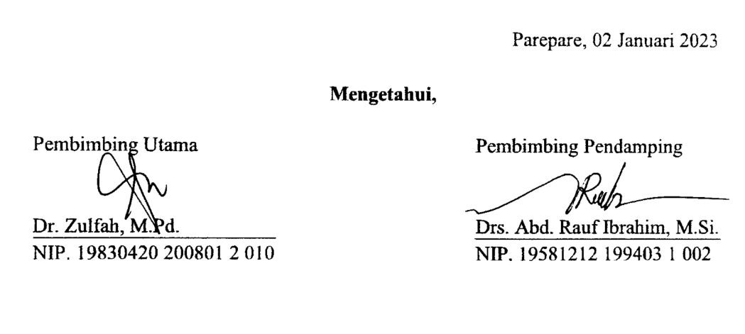
Parepare, 02 Januari 2023
Mengetahui,
Pembimbing Utama Pembimbing Pendamping
Dr. Zulfah, M.Pd. Drs. Abd. Rauf Ibrahim, M.Si.
NIP. 19830420 200801 2 010 NIP. 19581212 199403 1 002

KEMENTRIAN AGAMA
INSTITUT AGAMA ISLAM NEGERI (IAIN) PAREPARE
FAKULTAS TARBIYAH
Jl. Amal Bakti No. 8 Soreang 911331
Telepon (0421)21307, Faksimile (0421)2404
VALIDASI INSTRUMEN PENELITIAN PENULISAN SKRIPSI
Nama : Rahmatia Arman
NIM/Prodi : 18.1300.005/PBI
Fakultas : Tarbiyah
Judul penelitian : The Effect of Contextual Teaching Material on Students’ Reading Comprehension of The Second Grade of MA DDI Lil-Banat Parepare
POST-TEST ANSWER SHEET
INSTRUMENT OF EXPERIMENT CLASS
Name :
Class :
Read the text below and choose the correct answer for questions 1 - 10!
Jompie Botanical Garden is one of the botanical gardens in Indonesia which has an extensive natural urban forest area besides Bogor City. The location is about 3.5 km from downtown Parepare, precisely on Jl. Industri Kecil, Kel. Bukit Harapan, Kec. Soreang, Parepare City. It offers views of the tropical forest.
It was built in 1920 and stores biodiversity as well as being a tourist attraction and research center for tropical plants, especially Sulawesi endemic plants. It has an area of ​​13.5 hectares which is a center for conservation and also a collection of coastal plants of Wallacea, featuring a variety of medicinal, ethobotanical and indigenous plants. This botanical garden is also a way of environmental restoration so that it can help maintain food and water security.
Jompie Botanical Garden has 90 species of rare tropical plants from 81 plant genera. A total of 7 types of which have been identified in detail. Meanwhile, for the other 10 species, the plant genera have only been identified, and the other 3 species have only been identified at the tribal level. Some of them are known as rare plants.
In this botanical garden area, there are not only various types of plants, but also various facilities such as parks, swimming pools, freshwater habitat pools, 14 rest areas, camping areas, meeting rooms, towers to view the coast of Parepare City and interesting natural spots to take pictures.

- The text tells about .......
- Tropical plants in botanical garden
- Botanical Garden in Indomesia
- The biggest botanical garden
- Jompie Botanical Garden
- How big is that botanical garden?
- Thirteen and five acres
- Thirteen five acres
- Thirteen point five acres
- Thirty point five acres
- The word “indigenous” has the closest meaning with .....
- Fresh
- Native
- Modern
- New
- How many types of plants are included in rare plants which have not been identified at all in that botanical garden?
- 60
- 70
- 80
- 90
- Which is not the function of Jompie Botanical Garden is ......
- Research center for tropical plants
- Center for conservation and collection of coastal plants of Wallacea
- Plant exhibition
- Environmental restoration
- “Some of themare known ....”. The underlined wordrefers to .....
- Indigenous plants
- Rare tropical plants
- Coastal plants
- Ethobotanical
- What is Jompie Botanical Garden?
- Ordinary forest
- Natural urban forest
- Biggest forest
- A garden
- How many types of facilities mentioned in the text?
- 7
- 8
- 9
- 10
- What kind of text is it?
- Narrative text
- Explanation text
- Descriptive text
- Report text
- The word “extensive” has the opposite meaning with .....
- Large
- Narrow
- Isolated
- Domain

Parepare, 02 Januari 2023
Mengetahui,
Pembimbing Utama Pembimbing Pendamping
Dr. Zulfah, M.Pd. Drs. Abd. Rauf Ibrahim, M.Si.
NIP. 19830420 200801 2 010 NIP. 19581212 199403 1 002

KEMENTRIAN AGAMA
INSTITUT AGAMA ISLAM NEGERI (IAIN) PAREPARE
FAKULTAS TARBIYAH
Jl. Amal Bakti No. 8 Soreang 911331
Telepon (0421)21307, Faksimile (0421)2404
VALIDASI INSTRUMEN PENELITIAN PENULISAN SKRIPSI
Nama : Rahmatia Arman
NIM/Prodi : 18.1300.005/PBI
Fakultas : Tarbiyah
Judul penelitian : The Effect of Contextual Teaching Material on Students’ Reading Comprehension of The Second Grade of MA DDI Lil-Banat Parepare
PRE-TEST ANSWER SHEET
INSTRUMENT OF CONTROL CLASS
Name :
Class :
Read the text below and choose the correct answer for questions 1 - 10!
The Statue of Liberty Enlightening the World or mostly known as The Statue of Liberty is located in Liberty Island in New York Harbor, United States. This national building is symbol of freedom. It was a gift from The French to United States to celebrate the centennial of the American Declaration of Independence.
Liberty Statue is made of 3.16 inch thick of copper sheets. The appearance of the statue is believed to be representing the Roman goddess of freedom. Its right hand is holding a torch, and the left hand is holding a book with the date of the American Declaration of Independence written on it. The color of the statue was rusty brown, but after 30 years of oxidation process, it turns into green as we can see now.
The height of the statue measured from its base is 46 meters, but when it is measured from the ground, it is 93 meters. The height of the head is 14 feet. The width of the eye is 28 inches. The length of the nose is 3 feet 9 inches. The length of the forefinger is 8 feet. The total weight of the statue is 440.000 pounds.

- The text tells about .......
- American Declaration of Independence
- History of United States
- The statue of Liberty
- The statue in Liberty Island
- What was the first color of the statue of Liberty?
- Green
- Dusty brown
- Rusty brown
- Brown
- The word “measured” has similar meaning with .....
- Polished
- Gauged
- Molded
- Stretched
- What kind of text is it?
- Narrative
- Explanation
- Descriptive
- Report
- “it turns into ....”. The underlined word refers to ....
- The statue
- The color of the statue
- The book
- The torch
- What is the meaning of the statue?
- Symbol of wealth
- Symbol of unity
- Symbol of success
- Symbol of independence
- What is the reason this statue was built?
  - As a gift for the tenth anniversary of the American Declaration of Independence
  - As a gift for the centennial celebration of the American Declaration of Independence
  - As a gift for the centecial celebration of the American Declaration of Independence
  - As a gift for the American Declaration of Independence
- What is the statue made of?
  - Piece of copper
  - Gold sheets
  - Chopper sheets
  - Copper sheets

- What is the original size of the statue of Liberty?
- 46 meters
- 14 meters
- 28 meters
- 94 meters
- Which country gave the statue as a gift?
- United States
- Paris
- French
- Germany

Parepare, 02 Januari 2023
Mengetahui,
Pembimbing Utama Pembimbing Pendamping
Dr. Zulfah, M.Pd. Drs. Abd. Rauf Ibrahim, M.Si.
NIP. 19830420 200801 2 010 NIP. 19581212 199403 1 002

KEMENTRIAN AGAMA
INSTITUT AGAMA ISLAM NEGERI (IAIN) PAREPARE
FAKULTAS TARBIYAH
Jl. Amal Bakti No. 8 Soreang 911331
Telepon (0421)21307, Faksimile (0421)2404
VALIDASI INSTRUMEN PENELITIAN PENULISAN SKRIPSI
Nama : Rahmatia Arman
NIM/Prodi : 18.1300.005/PBI
Fakultas : Tarbiyah
Judul penelitian : The Effect of Contextual Teaching Material on Students’ Reading Comprehension of The Second Grade of MA DDI Lil-Banat Parepare
POST-TEST ANSWER SHEET
INSTRUMENT OF CONTROL CLASS
Name :
Class :
Read the text below and choose the correct answer for questions 1 - 10!
Taj Mahal or The Taj is a well known architectural object in India for its finest design which combine elements from India, Persian and Islamic architectural style. This historical building was built on the south bank of the Yamuna river in Agra. It represents the story of Eternal Love of the Mughal Emperor, Shah Jahan, to his dearest wife Mumtaz Mahal. In 1983 UNESCO place Taj Mahal into the list of World Heritage Site and consider it as “the jewel of Muslim art in India and one of the universally admired masterpieces of the world’s heritage”.
Taj Mahal is a very large tomb made of ivory-white marble. The building looks like a mosque, a place for a moslem to pray. Once we see it, we will get the impression that Islamic architectural style is very strong in the building, starting with the wall and the calligraphy decorations on it, a huge dome on top of the building along with 4 minarets on every corner of the base walls. The dome is also made of marble with size nearly 35 meters and the top of it is decorated with a lotus design. The minarets is also decorated with a very detailed lotus motif.
If we come from the main entrance, we will see a large pool in front of the building, this pool is called the reflecting pool as it will reflect the image of The Taj to the sky. Once we enter the building, we will find that there are more decorations on the inner wall. The tomb as the central focus of the building is located at the lower level. The graves of Mumtaz Mahal and Shah Jahan were positioned next to each other in a large room with Persian style decorations.

    - The text tells about .......
- Taj Mahal
- History Taj Mahal
- Shah Jahan
- Mumtaz Mahal
    - Which of the following is not true about Taj Mahal based on the text?
- A very large tomb made of ivory-white marble
- A tourists attraction in India
- A buliding represents the story of Eternal Love of the Mughal Emperor and his wife
- A building combines elements from India, Persian and Islamic architectural style
    - The word “heritage” has opposite meaning with .....
- Legacy
- Tenure
- Inheritance
- Patrimony
    - What kind of text is it?
- Narrative
- Explanation
- Descriptive
- Report
    - “and consider it as....”. The underlined word refers to ....
- UNESCO
- Taj Mahal
- World Heritage Site
- Mughal Emperor
    - Where does this building located?
  - East bank of the Yamuna river
  - North bank of the Yamuna river
  - South bank of the Yamuna river
  - South bank of the Yamana river
    - Who is Shah Jahan and Mumtaz Mahal?
  - Brother and sister
  - Married couple
  - Son and mother
  - Father and daughter
    - What is the Taj Mahal made of?
  - Ivory-yellow tiles
  - Ivory-yellow marble
  - Ivory-white marble
  - Ivory-white tiles
    - The design of Taj Mahal combines elements from .......
- Persian, Islamic, and India architectural style
- India, Islamic, and Persian architectural style
- Persian, India, and Islamic architectural style
- India, Persian, and Islamic architectural style
    - Why is it called reflecting pool?
- Because it will reflect the appearance of Taj Mahal to the sky
- Because it has a mirror in it
- Because Indians there call it that
- Because it will reflect our appearance

Parepare, 02Januari 2023
Mengetahui,
Pembimbing Utama Pembimbing Pendamping
Dr. Zulfah, M.Pd. Drs. Abd. Rauf Ibrahim, M.Si.
NIP. 19830420 200801 2 010 NIP. 19581212 199403 1 002

Appendix 2: Lesson plan
RENCANA PELAKSANAAN PEMBELAJARAN
Satuan Pendidikan : MA DDI Lil Banat Parepare
Mata Pelajaran : Bahasa Inggris
Kelas : XI IPS
Materi Pokok : Descriptive Text
Alokasi Waktu : 3 x 45 menit (1x pertemuan)

- Tujuan Pembelajaran
Setelah mengikuti proses pembelajaran, siswa diharapkan mampu mengindentifikasi makna, fungsi sosial, struktur teks dan unsur kebahasaan pada teks deskriptif sederhana.
- Kegiatan Pembelajaran
Kegiatan Pendahuluan
- Melakukan pembukaan dengan salam pembuka dan berdoa bersama untuk memulai pembelajaran, memeriksa kehadiran siswa, serta menciptakan kondisi belajar yang menyenangkan dengan melakukan warming up.
- Menyampaikan inti/garis besar cakupan materi, metode belajar yang akan ditempuh, serta memberikan motivasi mengenai manfaat mempelajari Bahasa Inggris sebelum memberikan materi.
Kegiatan Inti
- Peneliti memberikan materi tentang teks deskriptiflalu meminta siswa mengidentifikasi secara bersama-sama. Kemudian, siswa diberikan kesempatan untuk bertanya apabila ada yang belum dipahami.
- Peneliti membagikan paper yang berisi teks bacaan deskriptif yang kontekstual tentang “Tonrangeng River Side” dan melakukan brainstorming dengan mengaktifkan prior knowledge siswa dengan menanyakan apa yang mereka ketahui mengenai topik tersebut.
- Peneliti memberikan waktu beberapa menit kepada siswa untuk membaca dan memahami teks tersebut. Kemudian, peneliti meminta siswa untuk menjawab pertanyaan terkait teks bacaan kontekstual tersebut.
Kegiatan Penutup
- Peneliti mengevaluasi pemahaman siswa.
- Peneliti dan siswa menyimpulkan hasil pembelajaran.
- Menutup kegiatan pembelajaran dengan berdoa bersama dan memberikan salam penutup.
- Penilaian
- Teknik penilaian : tes tertulis
- Bentuk instrumen : soal pilihan ganda
- Instrumen : terlampir

Parepare, 19 Januari 2023
Mengetahui,
Guru Mata Pelajaran Mahasiswa

St. Mashita, S.Pd.I. Rahmatia Arman
NIP. NIM. 18.1300.005

TONRANGENG RIVER SIDE
Tonrangeng River Side is one of the most famous places in Parepare. It is a flyover that connects the Sumpang Bridge with the Type B+ Hospital which is decorated with sparkling colorful lights at night. Located in Lumpue, Kec. West Bacukiki, ParepareCity.
This flyover was built over the Karajae River with a width of 6 meters and a length of 125 meters. Both sides of the road are provided with sidewalks each approximately 1.5 meters wide as access for pedestrians. Meanwhile, in the middle of it, which is about 12 meters wide, a garden is made to make it look prettier. Along the flyover is decorated with colorful lights that will look very beautiful at night in green, white and orange.
In the southern side of Torangeng River Side, there is a green open space filled with lots of shady trees so it feels cool and fresh. While in the northern side there is a traditional culinary tour with a floating restaurant. There are also marine tours that take visitors to see the beauty of the Karajae River by using the boats provided.

- The text talks about .....
- Type B+ Hospital
- Tonrangeng River Side
- Sumpang Bridge
- Karajae River
- What are in the south and north sideof Torangeng River Side?
- Traditional culinary tour and green open space
- Garden and sidewalks
- Green open space and traditional culinary tour
- Green open space and garden
- The word “built” has similar meaning with ......
- Inaugurated
- Decided
- Established
- Arranged
- What is the name of the river mentioned in the text?
- Type B+
- Karajae
- Tonrangeng
- Sumpang
- “Meanwhile, in the middle of it, ....”. The underlined word refers to .....
- Pedestrians
- Flyover
- Sidewalks
- The road

RENCANA PELAKSANAAN PEMBELAJARAN
Satuan Pendidikan : MA DDI Lil Banat Parepare
Mata Pelajaran : Bahasa Inggris
Kelas : XI IPS
Materi Pokok : Descriptive Text
Alokasi Waktu : 3 x 45 menit (1x pertemuan)

- Tujuan Pembelajaran
Setelah mengikuti proses pembelajaran, siswa diharapkan mampu mengindentifikasi makna, fungsi sosial, struktur teks dan unsur kebahasaan pada teks deskriptif sederhana.
- Kegiatan Pembelajaran
Kegiatan Pendahuluan
- Melakukan pembukaan dengan salam pembuka dan berdoa bersama untuk memulai pembelajaran, memeriksa kehadiran siswa, serta menciptakan kondisi belajar yang menyenangkan dengan melakukan warming up.
- Menyampaikan inti/garis besar cakupan materi, metode belajar yang akan ditempuh, serta memberikan motivasi mengenai manfaat mempelajari Bahasa Inggris sebelum memberikan materi.
Kegiatan Inti
- Peneliti memberikan materi tentang teks deskriptiflalu meminta siswa mengidentifikasi secara bersama-sama. Kemudian, siswa diberikan kesempatan untuk bertanya apabila ada yang belum dipahami.
- Peneliti membagikan paper yang berisi teks bacaan deskriptif yang kontekstual tentang “Cempae Pavilion” dan melakukan brainstorming dengan mengaktifkan prior knowledge siswa dengan menanyakan apa yang mereka ketahui mengenai topik tersebut.
- Peneliti memberikan waktu beberapa menit kepada siswa untuk membaca dan memahami teks tersebut. Kemudian, peneliti meminta siswa untuk menjawab pertanyaan terkait teks bacaan kontekstual tersebut.
Kegiatan Penutup
- Peneliti mengevaluasi pemahaman siswa.
- Peneliti dan siswa menyimpulkan hasil pembelajaran.
- Menutup kegiatan pembelajaran dengan berdoa bersama dan memberikan salam penutup.
- Penilaian
- Teknik penilaian : tes tertulis
- Bentuk instrumen : soal pilihan ganda
- Instrumen : terlampir

Parepare, 21 Januari 2023
Mengetahui,
Guru Mata Pelajaran Mahasiswa

St. Mashita, S.Pd.I. Rahmatia Arman
NIP. NIM. 18.1300.005

CEMPAE PAVILION
Cempae Pavilion is a place that is in great demand by residents from within and outside the region and is one of the flagship projects of Parepare City in the tourism sector. Located on the coast of Cempae Beach, precisely on Jl. Tanggul Cempae, Wattang Soreang, Kec. Soreang, ParepareCity.
This pavilion was built on an area of ​​6.000 square meters and is a new icon of Parepare which was built in 2021. It has a modern and contemporary artistic building with a combination of yellow, green and orange which adds to its grandeur. In addition, the location of the development is very strategic, which is in the interior of Parepare Bay so that it will present a view of the beauty of the beach.
Various facilities are also available including toilets, a garden equipped with a place to relax, children's playground, food court area, and a special fishing pier. In addition, this place also has many photo spots. One of the favorite spots for visitors is the bridge on the left side of the pavilion. Visitors can watch the sunset on this bridge while taking selfies.

- The word “grandeur” has the similar meaning with, except .....
- Wealth
- Pomp
- Splendor
- Resplendence
- What does the third paragraph tell about?
- Location of Cempae Pavilion
- Facilities and photo spots of Cempae Pavilion
- History of Cempae Pavilion
- Facilities inCempae Pavilion
- How many facilities mentioned in the text?
- 4
- 5
- 6
- 7
- What is the kind of the text?
- Narrative text
- Descriptive text
- Report text
- Procedure text
- The statement that is not trueabout Cempae Pavilion is .......
- Located on the coast of Cempae Beach
- Has a modern artistic building
- Was established on an area of 6.000 square meters
- one of the flagship projects in the economy sector

RENCANA PELAKSANAAN PEMBELAJARAN
Satuan Pendidikan : MA DDI Lil Banat Parepare
Mata Pelajaran : Bahasa Inggris
Kelas : XI IPS
Materi Pokok : Descriptive Text
Alokasi Waktu : 3 x 45 menit (1x pertemuan)

- Tujuan Pembelajaran
Setelah mengikuti proses pembelajaran, siswa diharapkan mampu mengindentifikasi makna, fungsi sosial, struktur teks dan unsur kebahasaan pada teks deskriptif sederhana.
- Kegiatan Pembelajaran
Kegiatan Pendahuluan
- Melakukan pembukaan dengan salam pembuka dan berdoa bersama untuk memulai pembelajaran, memeriksa kehadiran siswa, serta menciptakan kondisi belajar yang menyenangkan dengan melakukan warming up.
- Menyampaikan inti/garis besar cakupan materi, metode belajar yang akan ditempuh, serta memberikan motivasi mengenai manfaat mempelajari Bahasa Inggris sebelum memberikan materi.
Kegiatan Inti
- Peneliti memberikan materi tentang teks deskriptiflalu meminta siswa mengidentifikasi secara bersama-sama. Kemudian, siswa diberikan kesempatan untuk bertanya apabila ada yang belum dipahami.
- Peneliti membagikan paper yang berisi teks bacaan deskriptif yang kontekstual tentang “Lumpue Beach” dan melakukan brainstorming dengan mengaktifkan prior knowledge siswa dengan menanyakan apa yang mereka ketahui mengenai topik tersebut.
- Peneliti memberikan waktu beberapa menit kepada siswa untuk membaca dan memahami teks tersebut. Kemudian, peneliti meminta siswa untuk menjawab pertanyaan terkait teks bacaan kontekstual tersebut.
Kegiatan Penutup
- Peneliti mengevaluasi pemahaman siswa.
- Peneliti dan siswa menyimpulkan hasil pembelajaran.
- Menutup kegiatan pembelajaran dengan berdoa bersama dan memberikan salam penutup.
- Penilaian
- Teknik penilaian : tes tertulis
- Bentuk instrumen : soal pilihan ganda
- Instrumen : terlampir

Parepare, 25 Januari 2023
Mengetahui,
Guru Mata Pelajaran Mahasiswa

St. Mashita, S.Pd.I. Rahmatia Arman
NIP. NIM. 18.1300.005

LUMPUE BEACH
Lumpue Beach is the oldest beach in Parepare City and is quite popular among the people. It has a beautiful scenery that is still natural. Located on Jl. Pinggir Laut No. 18, Lumpue, Kec. Bacukiki Barat, Parepare City.
This beach has been known since around the 1950s. It is often used as a boat mooring by fishermen after fishing on the high seas. Fishermen leave early in the morning and then return in the evening or when the sun is about to rise. On that basis, it is also known as the Butterfly Beach.
This beach provides a view of blackish-green water that looks exotic combined with fine brownish white sand. The combination of contrasting colors of sea water and shady trees on the shores of the beach further adds to the beauty of this beach. In addition, there is a low rocky hill at the end of the beach which is decorated with rows of small caves that are beautiful and interesting to take a closer look at.Public facilities are also available on this beach such as bathrooms, parking lots, places of worship, as well as gazebos and diving equipment that can be rented.

- What facilities are not available for free based on the text?
- Bathrooms
- Gazebos
- Places of worship
- Parking lots
- Why that beach also called as Butterfly Beach?
- Because often used as a boat mooring
- Because it’s a place for butterflies breed
- Because butterflies were first discovered there
- Because there are many butterflies there
- The word “equipment” has the opposite meaning with .....
- Tool
- Needs
- Apparatus
- Means
- What does paragraph 2 mainly discuss?
- Location of Lumpue Beach
- Facilities inLumpue Beach
- View ofLumpue Beach
- History of Lumpue Beach
- “It is often used as ....”. The underlined word refers to .....
- Parepare City
- Lumpue Beach
- Beach
- Fisherman

RENCANA PELAKSANAAN PEMBELAJARAN
Satuan Pendidikan : MA DDI Lil Banat Parepare
Mata Pelajaran : Bahasa Inggris
Kelas : XI IPS
Materi Pokok : Descriptive Text
Alokasi Waktu : 3 x 45 menit (1x pertemuan)

- Tujuan Pembelajaran
Setelah mengikuti proses pembelajaran, siswa diharapkan mampu mengindentifikasi makna, fungsi sosial, struktur teks dan unsur kebahasaan pada teks deskriptif sederhana.
- Kegiatan Pembelajaran
Kegiatan Pendahuluan
- Melakukan pembukaan dengan salam pembuka dan berdoa bersama untuk memulai pembelajaran, memeriksa kehadiran siswa, serta menciptakan kondisi belajar yang menyenangkan dengan melakukan warming up.
- Menyampaikan inti/garis besar cakupan materi, metode belajar yang akan ditempuh, serta memberikan motivasi mengenai manfaat mempelajari Bahasa Inggris sebelum memberikan materi.
Kegiatan Inti
- Peneliti memberikan materi tentang teks deskriptiflalu meminta siswa mengidentifikasi secara bersama-sama. Kemudian, siswa diberikan kesempatan untuk bertanya apabila ada yang belum dipahami.
- Peneliti membagikan paper yang berisi teks bacaan deskriptif yang kontekstual tentang “Paputo Beach” dan melakukan brainstorming dengan mengaktifkan prior knowledge siswa dengan menanyakan apa yang mereka ketahui mengenai topik tersebut.
- Peneliti memberikan waktu beberapa menit kepada siswa untuk membaca dan memahami teks tersebut. Kemudian, peneliti meminta siswa untuk menjawab pertanyaan terkait teks bacaan kontekstual tersebut.
Kegiatan Penutup
- Peneliti mengevaluasi pemahaman siswa.
- Peneliti dan siswa menyimpulkan hasil pembelajaran.
- Menutup kegiatan pembelajaran dengan berdoa bersama dan memberikan salam penutup.
- Penilaian
- Teknik penilaian : tes tertulis
- Bentuk instrumen : soal pilihan ganda
- Instrumen : terlampir

Parepare, 26 Januari 2023
Mengetahui,
Guru Mata Pelajaran Mahasiswa

St. Mashita, S.Pd.I. Rahmatia Arman
NIP. NIM. 18.1300.005

PAPUTO BEACH
Paputo Beach is one of the famous beaches in Parepare because of its natural beauty. On this beach visitor can enjoy the coast with fine white sand. The name Paputo stands for "Pantai Pasir Putih Tonrangeng". Located on Jl. Latasakka, Lumpue, Kec. Bacukiki Barat, Parepare City. The location is not far from the border of Barru Regency.
As the name implies, the beautiful stretch of white sand is the main attraction of this beach. Paputo has a fairly large open area making it suitable as a place to hold reunions, gatherings and company outings. This beach provides many places to just sit back and enjoy a variety of food and drinks. There are rows of colorful gazebos near the beach which are made as attractive as possible with the addition of colorful bean bags complete with small umbrellas that cover the gazebo from the sun. Not only that, there are also wooden seats and an ordinary wooden gazebo on this beach. Rows of coconut trees on the shore also add to the comfort of this place, moreover, these trees can also be used to install hammocks.
Paputo Beach provides a variety of interesting photo spots. There is a swing that directly faces the sea as the most favorite spot. There are also Instagram-style photo spot, and there are many other spots that can describe the beauty of this beach scene.
The facilities on Paputo beach can be said to be adequate and complete. There are very clean and adequate toilets and rinse rooms, quite a lot of disposal bins, and a cafe that offers direct views of the beach complete with a special menus. Not only that, the manager also provides additional rides for children's playgrounds in the form of a seesaw.
- What does the third paragraph tell about?
- History of Paputo Beach
- Location of Paputo Beach
- Interesting photo spots in Paputo Beach
- Facilities on Paputo Beach
- The word “adeqaute” in paragraph 4 has the closest meaning with ......
- Large
- Satisfy
- Nice
- Terrible
- What is Paputo stand for?
- Pantai Putih Pasir Tonrangeng
- Pasir Putih Tonrangeng
- Pantai Pasir Putih Tonrangeng
- Pasir Pantai Putih Tonrangeng
- The following are the facilities in Paputo mentioned in the text, except ......
- Garbage dumps
- Parking area
- Toilet
- Gazebos
- What is the purpose of the text?
- To describe Paputo Beach
- To inform people the new beach in Parepare
- To persuade someone to visitPaputo Beach
- To explain one of beaches in Parepare

RENCANA PELAKSANAAN PEMBELAJARAN
Satuan Pendidikan : MA DDI Lil Banat Parepare
Mata Pelajaran : Bahasa Inggris
Kelas : XI IPA
Materi Pokok : Descriptive Text
Alokasi Waktu : 3 x 45 menit (1x pertemuan)

- Tujuan Pembelajaran
Setelah mengikuti proses pembelajaran, siswa diharapkan mampu mengindentifikasi makna, fungsi sosial, struktur teks dan unsur kebahasaan pada teks deskriptif sederhana.
- Kegiatan Pembelajaran
Kegiatan Pendahuluan
- Melakukan pembukaan dengan salam pembuka dan berdoa bersama untuk memulai pembelajaran, memeriksa kehadiran siswa, serta menciptakan kondisi belajar yang menyenangkan dengan melakukan warming up.
- Menyampaikan inti/garis besar cakupan materi, metode belajar yang akan ditempuh, serta memberikan motivasi mengenai manfaat mempelajari Bahasa Inggris sebelum memberikan materi.
Kegiatan Inti
- Peneliti memberikan materi tentang teks deskriptiflalu meminta siswa mengidentifikasi secara bersama-sama. Kemudian, siswa diberikan kesempatan untuk bertanya apabila ada yang belum dipahami.
- Peneliti membagikan paper yang berisi teks bacaan deskriptif tentang “Maimun Palace” dan melakukan brainstorming dengan mengaktifkan prior knowledge siswa dengan menanyakan apa yang mereka ketahui mengenai topik tersebut.
- Peneliti memberikan waktu beberapa menit kepada siswa untuk membaca dan memahami teks tersebut. Kemudian, peneliti meminta siswa untuk menjawab pertanyaan terkait teks bacaan tersebut.
Kegiatan Penutup
- Peneliti mengevaluasi pemahaman siswa.
- Peneliti dan siswa menyimpulkan hasil pembelajaran.
- Menutup kegiatan pembelajaran dengan berdoa bersama dan memberikan salam penutup.
- Penilaian
- Teknik penilaian : tes tertulis
- Bentuk instrumen : soal pilihan ganda
- Instrumen : terlampir

Parepare, 21 Januari 2023
Mengetahui,
Guru Mata Pelajaran Mahasiswa

St. Mashita, S.Pd.I. Rahmatia Arman
NIP. NIM. 18.1300.005

MAIMUN PALACE
Maimun Palace is a tourist destination in North Sumatra which has historical and cultural values.Located at Jalan Brigjen Katamso,Aur,Medan, this palace is iconic to Medan.
The building stands on an area of 2,772 square meters and is the heritage of the Deli Sultanate. It was designed by an Italian architect and built in 1888 under the rule of Sultan Makmun Al Rasyid Perkasa, the Sultan of Deli.
The palace has stunning architecture. It combines Islamic, Dutch and Malay architectures, with a dominant color of yellow, typical of Malay. This two-storey building is divided into three parts,namely, the main building, left and right wing parts. It is supported by 82 octagonal stone pillars and 42 wooden pillars.
The first floor displays antiques such as old furniture and ornaments, while the second floor us used as residence of sultanate families. There are 13 rooms on the second floor, 7 of which are in the main building, 3 rooms in the left wing part and 3 other rooms in the right wing part.

- What is the purpose of the text?
- To relate Deli Sultanate.
- To describe Maimun Palace
- To entertain readers.
- To describe a palace architecture
- The palace architecture combines....
  - Islamic, Malay and Dutch
  - Malay, Dutch and Turkish
  - Islamic, Dutch and Malay
  - Malay, Islamic and Dutch
- "It combines Islamic, Dutch and Malay architectures,...". 'It' refers to ....
  - Malay architecture
  - the Deli Sultanate
  - The main building
  - Maimun Palace
- What is the dominant color of the palace?
  - Red
  - Yellow
  - Green
  - Blue
- From the text we know that ....
  - Maimun Palace is the heritage of the Deli Sultanate
  - Maimun Palace was designed by the Sultan of Deli
  - Maimun Palace covers an area of 2,727m^2
  - Maimun Palace is a three-storey building with two main parts
RENCANA PELAKSANAAN PEMBELAJARAN
Satuan Pendidikan : MA DDI Lil Banat Parepare
Mata Pelajaran : Bahasa Inggris
Kelas : XI IPA
Materi Pokok : Descriptive Text
Alokasi Waktu : 3 x 45 menit (1x pertemuan)

- Tujuan Pembelajaran
Setelah mengikuti proses pembelajaran, siswa diharapkan mampu mengindentifikasi makna, fungsi sosial, struktur teks dan unsur kebahasaan pada teks deskriptif sederhana.
- Kegiatan Pembelajaran
Kegiatan Pendahuluan
- Melakukan pembukaan dengan salam pembuka dan berdoa bersama untuk memulai pembelajaran, memeriksa kehadiran siswa, serta menciptakan kondisi belajar yang menyenangkan dengan melakukan warming up.
- Menyampaikan inti/garis besar cakupan materi, metode belajar yang akan ditempuh, serta memberikan motivasi mengenai manfaat mempelajari Bahasa Inggris sebelum memberikan materi.
Kegiatan Inti
- Peneliti memberikan materi tentang teks deskriptiflalu meminta siswa mengidentifikasi secara bersama-sama. Kemudian, siswa diberikan kesempatan untuk bertanya apabila ada yang belum dipahami.
- Peneliti membagikan paper yang berisi teks bacaan deskriptif tentang “Petruk Cave” dan melakukan brainstorming dengan mengaktifkan prior knowledge siswa dengan menanyakan apa yang mereka ketahui mengenai topik tersebut.
- Peneliti memberikan waktu beberapa menit kepada siswa untuk membaca dan memahami teks tersebut. Kemudian, peneliti meminta siswa untuk menjawab pertanyaan terkait teks bacaan tersebut.
Kegiatan Penutup
- Peneliti mengevaluasi pemahaman siswa.
- Peneliti dan siswa menyimpulkan hasil pembelajaran.
- Menutup kegiatan pembelajaran dengan berdoa bersama dan memberikan salam penutup.
- Penilaian
- Teknik penilaian : tes tertulis
- Bentuk instrumen : soal pilihan ganda
- Instrumen : terlampir

Parepare, 26 Januari 2023
Mengetahui,
Guru Mata Pelajaran Mahasiswa

St. Mashita, S.Pd.I. Rahmatia Arman
NIP. NIM. 18.1300.005

PETRUK CAVE
Petruk cave is one of the leading tourist attractions in Kebumen, Central Java. The cave is located in the dukuh Mandayana Candirenggo Village, Ayah District, Kebumen Regency. In the petruk cave there is no lighting that illuminates the cave. It is still very natural cave so that petruk cave is very dark to be entered. Petruk cave’s name is taken from the punokawan of puppet characters that is Petruk. The cave named Petruk Cave because the length of cave is as long as petruk’s nose.
In the cave there are 3 floors that are the first is a basic cave, Hindu caves and Petruk cave. The base cave is a short cave which is just 100 meters away. The cave is used for tourist attractions. Hindu cave is part of the cave that is usually used to put offerings to the ancestor. Inside Petruk cave there are so many stalactites and stalagmites which are really awesome. If you want to explore this cave, you must be led by guides who are ready to take you through the cave. After arriving at the end of the cave, you can see the beach or waterfall located near at the end of the cave.

- What is the text purpose?
  - To inform about tourism in Kebumen
  - To explain about floors in Petruk Cave
  - To introduce The Local tourism in Kebumen
  - To describe Petruk Cave
- Why is it named as Petruk Cave?
  - Because the cave is belong to Petruk
  - Because the cave’s length is as long as Petruk’s nose
  - Because Petruk is the first explorer of the cave
  - Because Petruk is buried at the cave
- Which part of it which used for place to put foods for ancestor?
  - In the basic cave
  - In Petruk cave
  - In Hindu cave
  - Inside the cave
- What does stalactites mean?
  - A type of formation that hangs from the ceiling of caves
  - Types of formation that lay on the floor of caves
  - Types of food given to ancestor
  - Kind of animals in the cave
- What does “lead” mean in paragraph 2?
  - Guide
  - Take
  - Bring
  - Put

RENCANA PELAKSANAAN PEMBELAJARAN
Satuan Pendidikan : MA DDI Lil Banat Parepare
Mata Pelajaran : Bahasa Inggris
Kelas : XI IPA
Materi Pokok : Descriptive Text
Alokasi Waktu : 3 x 45 menit (1x pertemuan)

- Tujuan Pembelajaran
Setelah mengikuti proses pembelajaran, siswa diharapkan mampu mengindentifikasi makna, fungsi sosial, struktur teks dan unsur kebahasaan pada teks deskriptif sederhana.
- Kegiatan Pembelajaran
Kegiatan Pendahuluan
- Melakukan pembukaan dengan salam pembuka dan berdoa bersama untuk memulai pembelajaran, memeriksa kehadiran siswa, serta menciptakan kondisi belajar yang menyenangkan dengan melakukan warming up.
- Menyampaikan inti/garis besar cakupan materi, metode belajar yang akan ditempuh, serta memberikan motivasi mengenai manfaat mempelajari Bahasa Inggris sebelum memberikan materi.
Kegiatan Inti
- Peneliti memberikan materi tentang teks deskriptiflalu meminta siswa mengidentifikasi secara bersama-sama. Kemudian, siswa diberikan kesempatan untuk bertanya apabila ada yang belum dipahami.
- Peneliti membagikan paper yang berisi teks bacaan deskriptif tentang “National Monument” dan melakukan brainstorming dengan mengaktifkan prior knowledge siswa dengan menanyakan apa yang mereka ketahui mengenai topik tersebut.
- Peneliti memberikan waktu beberapa menit kepada siswa untuk membaca dan memahami teks tersebut. Kemudian, peneliti meminta siswa untuk menjawab pertanyaan terkait teks bacaan tersebut.
Kegiatan Penutup
- Peneliti mengevaluasi pemahaman siswa.
- Peneliti dan siswa menyimpulkan hasil pembelajaran.
- Menutup kegiatan pembelajaran dengan berdoa bersama dan memberikan salam penutup.
- Penilaian
- Teknik penilaian : tes tertulis
- Bentuk instrumen : soal pilihan ganda
- Instrumen : terlampir

Parepare, 29 Januari 2023
Mengetahui,
Guru Mata Pelajaran Mahasiswa

St. Mashita, S.Pd.I. Rahmatia Arman
NIP. NIM. 18.1300.005

NATIONAL MONUMENT
The National Monument or usually called as Monas is located in Central Jakarta, Indonesia. This monument was built in 1961 with the purpose to commemorate the struggle and fight of the people in Indonesia to achieve their independence. It was opened to the public in 1975.
The National Monument is a rectangular tower with the height of 132 meters. The typical part of the building that became a special characteristic of it is the flame shape covered with gold foil located on the top of the tower. There is a museum at the base part of the tower with the size of 80 x 80 meters, and everyone can visit it to learn the history of Indonesia. There is also an amphitheater in this building called Ruang Kemerdekaan, it is located in the cup part of Monas and it can be reached by using spiral stairs at the north and south doors. If you go to the southern side of the building, you will find an elevator that can be use to access the top platform where we will find the observation deck and also the flame of independence.

- What kind of text above?
- Daily news
- Descriptive text
- Narrative text
- Report text
- Based on the text, what is located at the top of Monas?
- An amphitheater
- A museum
- A flame shape covered with gold foil
- A spiral stairs
- “...everyone can visit it to learn...”. The underlined word refers to ....
- Monas
- Museum
- Amphitheater
- Elevator
- The unique characteristic of Monas is ....
- The amphitheater
- The museum
- The flame shape covered with gold foil
- The spiral stairs
- What is the function of the spiral stairs?
- To access the museum
- To access the flame shape
- To access the top platform
- To access the amphitheater

RENCANA PELAKSANAAN PEMBELAJARAN
Satuan Pendidikan : MA DDI Lil Banat Parepare
Mata Pelajaran : Bahasa Inggris
Kelas : XI IPA
Materi Pokok : Descriptive Text
Alokasi Waktu : 3 x 45 menit (1x pertemuan)

- Tujuan Pembelajaran
Setelah mengikuti proses pembelajaran, siswa diharapkan mampu mengindentifikasi makna, fungsi sosial, struktur teks dan unsur kebahasaan pada teks deskriptif sederhana.
- Kegiatan Pembelajaran
Kegiatan Pendahuluan
- Melakukan pembukaan dengan salam pembuka dan berdoa bersama untuk memulai pembelajaran, memeriksa kehadiran siswa, serta menciptakan kondisi belajar yang menyenangkan dengan melakukan warming up.
- Menyampaikan inti/garis besar cakupan materi, metode belajar yang akan ditempuh, serta memberikan motivasi mengenai manfaat mempelajari Bahasa Inggris sebelum memberikan materi.
Kegiatan Inti
- Peneliti memberikan materi tentang teks deskriptiflalu meminta siswa mengidentifikasi secara bersama-sama. Kemudian, siswa diberikan kesempatan untuk bertanya apabila ada yang belum dipahami.
- Peneliti membagikan paper yang berisi teks bacaan deskriptif tentang “Kuta Beach” dan melakukan brainstorming dengan mengaktifkan prior knowledge siswa dengan menanyakan apa yang mereka ketahui mengenai topik tersebut.
- Peneliti memberikan waktu beberapa menit kepada siswa untuk membaca dan memahami teks tersebut. Kemudian, peneliti meminta siswa untuk menjawab pertanyaan terkait teks bacaan tersebut.
Kegiatan Penutup
- Peneliti mengevaluasi pemahaman siswa.
- Peneliti dan siswa menyimpulkan hasil pembelajaran.
- Menutup kegiatan pembelajaran dengan berdoa bersama dan memberikan salam penutup.
- Penilaian
- Teknik penilaian : tes tertulis
- Bentuk instrumen : soal pilihan ganda
- Instrumen : terlampir

Parepare, 31 Januari 2023
Mengetahui,
Guru Mata Pelajaran Mahasiswa

St. Mashita, S.Pd.I. Rahmatia Arman
NIP. NIM. 18.1300.005

KUTA BEACH
Kuta is a very beautiful beach. Kuta beach located in Badung regency. It’s close to the Ngurah Rai airport and is about 9 km from Denpasar. Kuta is a beach that is very popular both in Indonesia and International.
In Kuta beach, there are a variety of facilities including accommodation, restaurant, bar, as well as a very famous surfing spots in the world. In Kuta beach, you will see a lot of tourists with a variety of activities in which they live. The usual tourist will take the time for sunbathing, kite flying, playing volleyball, walking around, and playing beach soccer. This is a beach that is very crowded every day.
The activity in Kuta beach is not only takes place during the day, but also in the night. Various types of pubs and restaurants provide night hours for visitors so they can enjoy a meal and entertainment throughout the night. The night life at Kuta beach starts at 23:00.

- What is closest to the beach based on the text?
- Badung regency
- Ngurah Rai airport
- Denpasar
- Downtown
- Based on the text, in which paragraph are the facilities and activities on Kuta beach explained?
- 1
- 2
- 3
- 2 and 3
- What activities are usually carried out by tourists on the beach, except .....
- Sunbathing
- Playing badmintoon
- Playing volleyball
- Kite flying
- The word “crowded” has the similar meaning with ....
- Packed
- Deserted
- Maintained
- Trusted
- How many facilities are mentioned in the text?
- 3
- 4
- 5
- 6
Appendix 3: Students’ pre-test and post-test of experimental class
- Students’ Pre-test
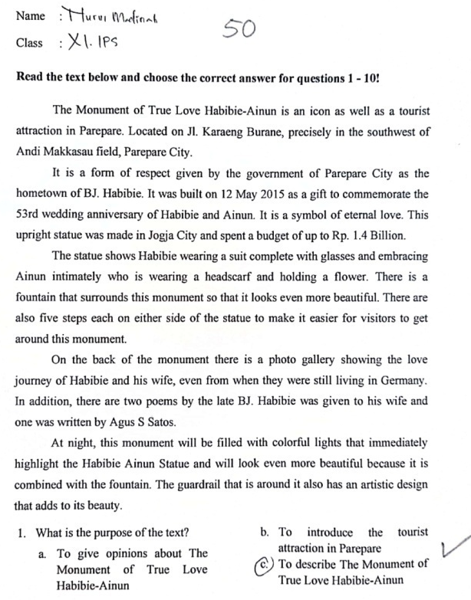
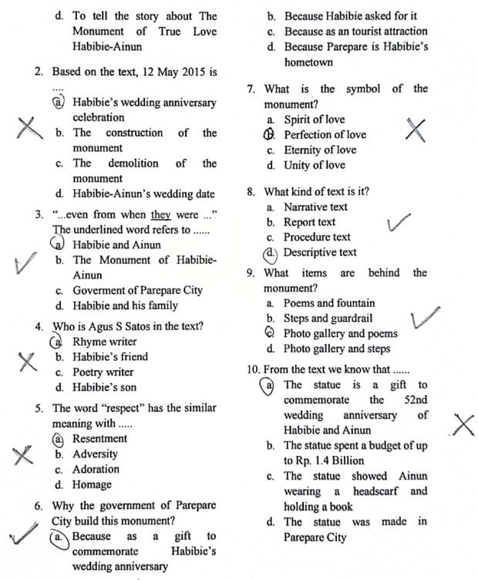
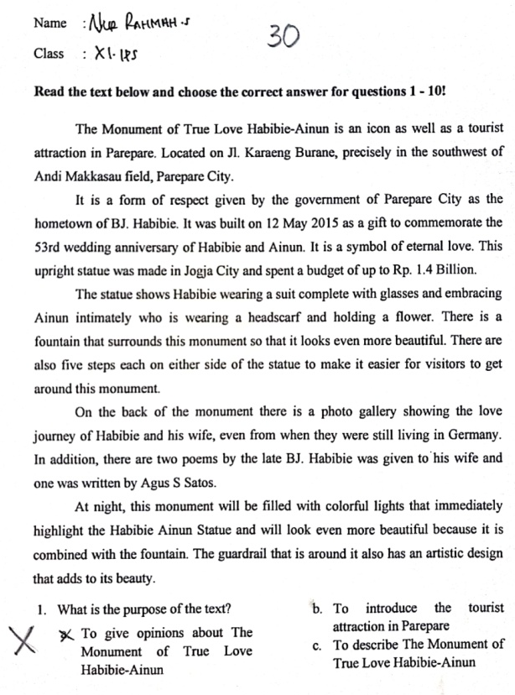
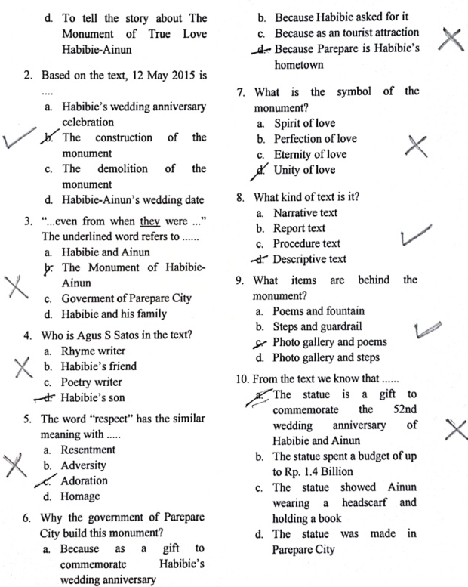
- Students’ Post-test
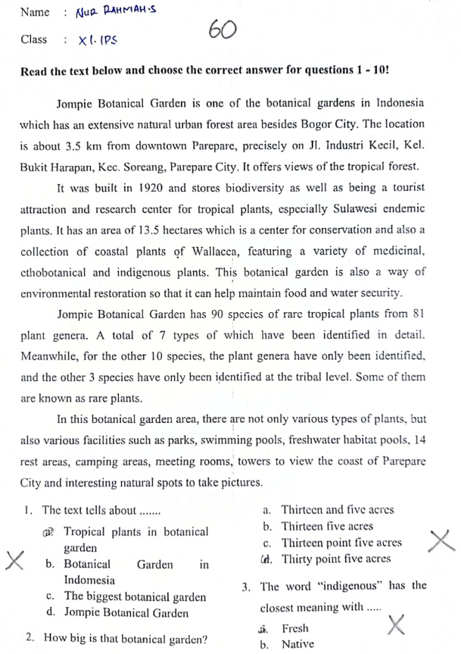
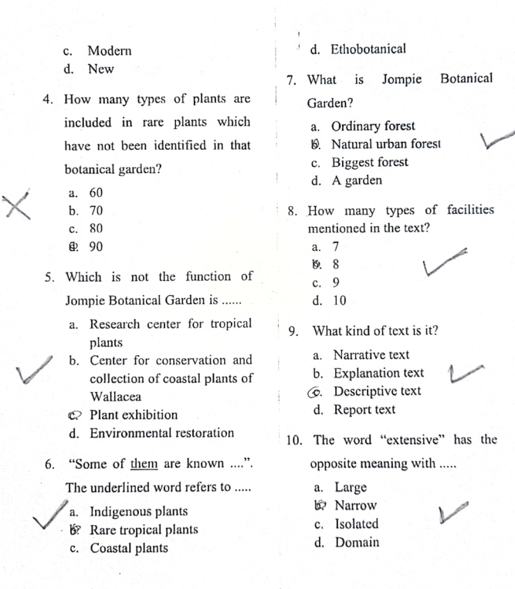

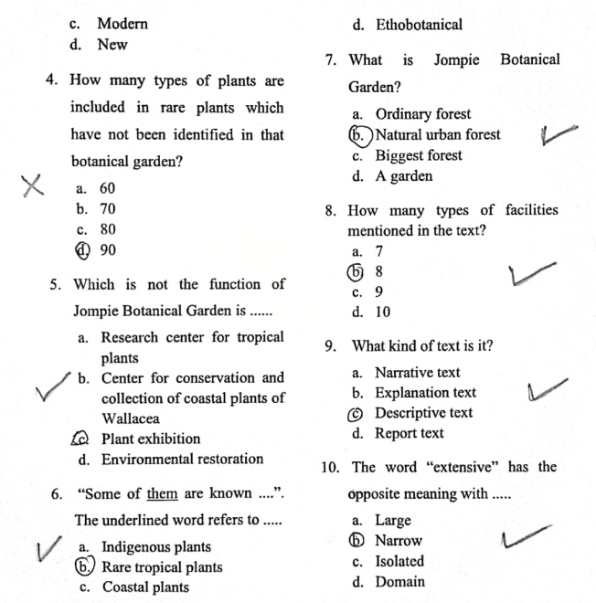
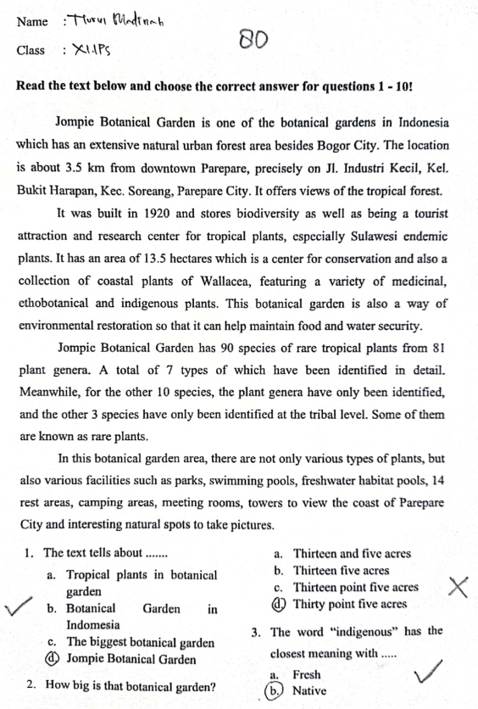
Appendix 4: Students’ pre-test and post-test of control class
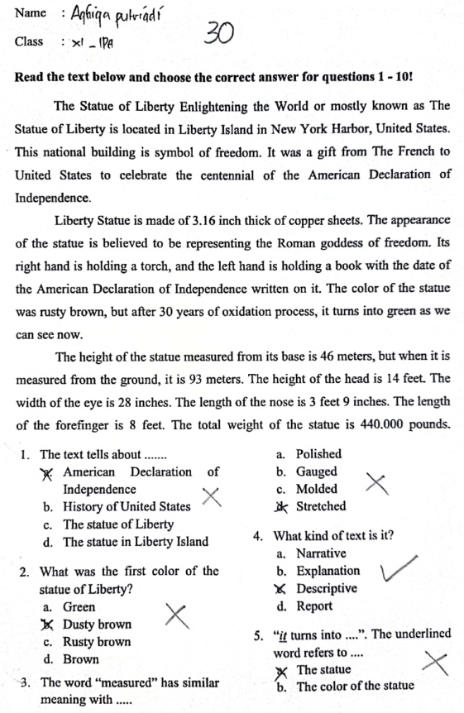
- Students’ Pre-test

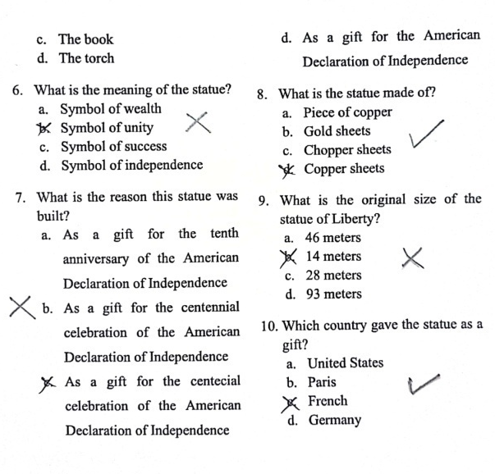

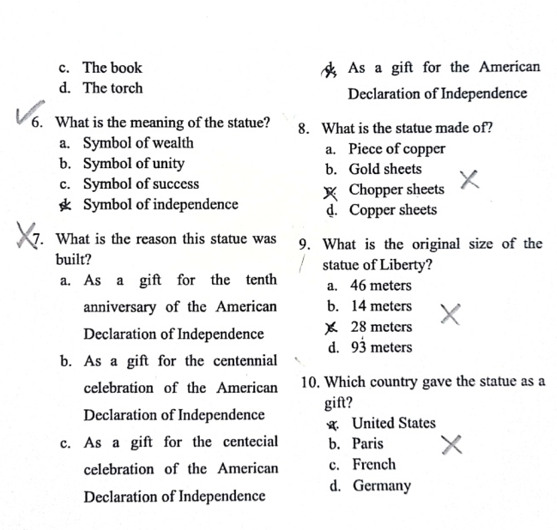
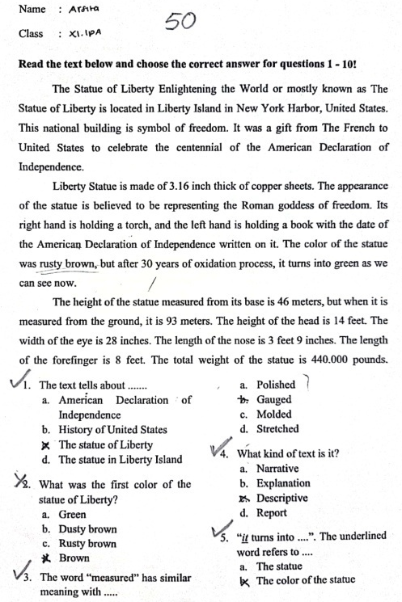
- Students’ Post-test
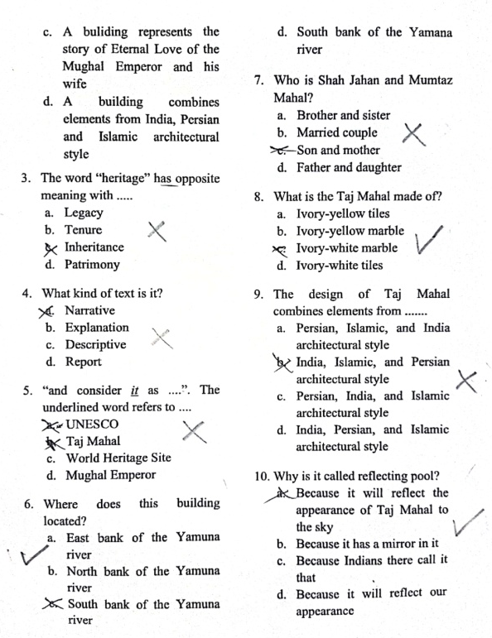
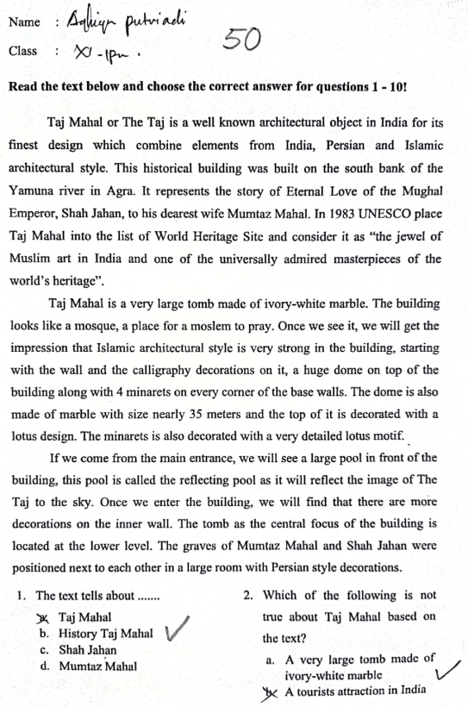

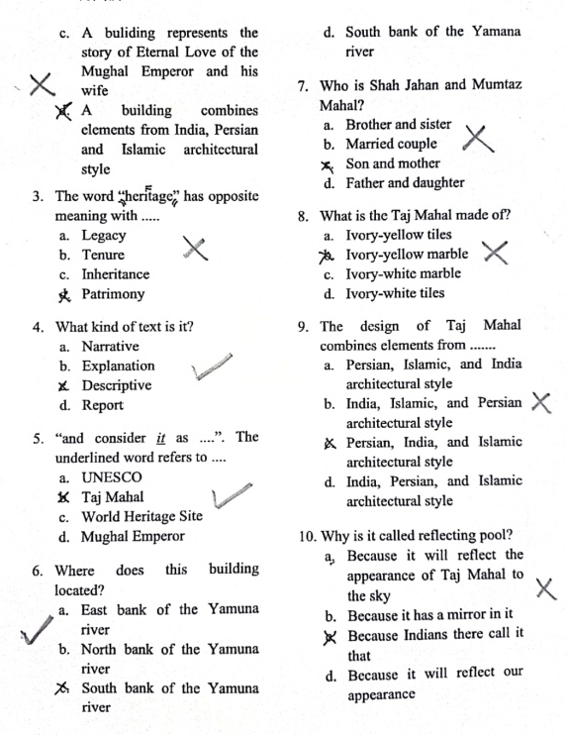
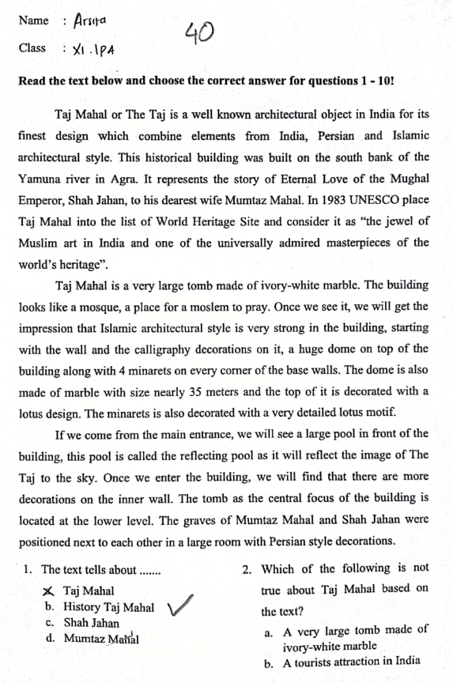
Appendix 5: Students’ pre-test and post-test in experimental and control class
    - Data of Experimental Class
- Students’ Score in Pre-Test
Students Name | Correct Answer | Score | Classification
S1 | 8 | 80 | Good
S2 | 6 | 60 | Fair
S3 | 7 | 70 | Fair
S4 | 4 | 40 | Very Poor
S5 | 8 | 70 | Fair
S6 | 3 | 30 | Very Poor
S7 | 4 | 40 | Very Poor
S8 | 5 | 50 | Poor
S9 | 6 | 60 | Fair
S10 | 4 | 40 | Very Poor
S11 | 4 | 40 | Very Poor
S12 | 6 | 60 | Fair
S13 | 3 | 30 | Very Poor
S14 | 4 | 40 | Very Poor
S15 | 5 | 50 | Poor
S16 | 5 | 50 | Poor
S17 | 3 | 30 | Very Poor
S18 | 3 | 30 | Very Poor
S19 | 5 | 50 | Poor
S20 | 2 | 20 | Very Poor

- Students’ Score in Post-Test
Students Name | Correct Answer | Score | Classification
S1 | 5 | 60 | Fair
S2 | 3 | 30 | Very Poor
S3 | 8 | 90 | Excellent
S4 | 4 | 50 | Poor
S5 | 8 | 90 | Excellent
S6 | 4 | 50 | Poor
S7 | 6 | 70 | Fair
S8 | 4 | 50 | Poor
S9 | 7 | 80 | Good
S10 | 8 | 90 | Excellent
S11 | 6 | 70 | Fair
S12 | 7 | 80 | Good
S13 | 6 | 60 | Fair
S14 | 8 | 90 | Excellent
S15 | 8 | 80 | Good
S16 | 4 | 50 | Poor
S17 | 4 | 50 | Poor
S18 | 8 | 90 | Excellent
S19 | 5 | 60 | Fair
S20 | 4 | 50 | Poor

- Pre-testand Post-test Scores of Students in Experimental Class
Students Name | Pre-test | Post-test | X | X²
S1 | 80 | 60 | -20 | 400
S2 | 60 | 30 | -30 | 900
S3 | 70 | 90 | 20 | 400
S4 | 40 | 50 | 10 | 100
S5 | 70 | 90 | 20 | 400
S6 | 30 | 50 | 20 | 400
S7 | 40 | 70 | 30 | 900
S8 | 50 | 50 | 0 | 0
S9 | 60 | 80 | 20 | 400
S10 | 40 | 90 | 50 | 2500
S11 | 40 | 70 | 30 | 900
S12 | 60 | 80 | 20 | 400
S13 | 30 | 60 | 30 | 900
S14 | 40 | 90 | 50 | 2500
S15 | 50 | 80 | 30 | 900
S16 | 50 | 50 | 0 | 0
S17 | 30 | 50 | 20 | 400
S18 | 30 | 90 | 60 | 3600
S19 | 50 | 60 | 10 | 100
S20 | 20 | 50 | 30 | 900
 | 940 | 1340 | 400 | 17000
Mean Score |  |  | 20

    - Data of Control Class
- Students’ Score in Pre-Test
Students Name | Correct Answer | Score | Classification
S1 | 5 | 50 | Poor
S2 | 5 | 50 | Poor
S3 | 1 | 10 | Very Poor
S4 | 6 | 60 | Fair
S5 | 3 | 30 | Very Poor
S6 | 5 | 50 | Poor
S7 | 1 | 10 | Very Poor
S8 | 3 | 30 | Very Poor
S9 | 5 | 50 | Poor
S10 | 2 | 20 | Very Poor
S11 | 4 | 40 | Very Poor
S12 | 5 | 50 | Poor
S13 | 3 | 30 | Very Poor
S14 | 7 | 70 | Fair
S15 | 2 | 20 | Very Poor
S16 | 5 | 50 | Poor
S17 | 6 | 60 | Fair
S18 | 5 | 50 | Poor

- Students’ Score in Post-Test
Students Name | Correct Answer | Score | Classification
S1 | 2 | 20 | Very Poor
S2 | 9 | 80 | Good
S3 | 5 | 40 | Very Poor
S4 | 7 | 70 | Fair
S5 | 5 | 50 | Poor
S6 | 4 | 40 | Very Poor
S7 | 5 | 50 | Poor
S8 | 8 | 60 | Fair
S9 | 9 | 80 | Good
S10 | 6 | 60 | Fair
S11 | 4 | 40 | Very Poor
S12 | 8 | 50 | Poor
S13 | 5 | 40 | Very Poor
S14 | 6 | 60 | Fair
S15 | 3 | 20 | Very Poor
S16 | 6 | 60 | Fair
S17 | 6 | 60 | Fair
S18 | 4 | 30 | Very Poor

- Pre-testand Post-test Scores of Students in Control Class
Students Name | Pre-test | Post-test | X | X²
S1 | 50 | 20 | -30 | 900
S2 | 50 | 80 | 30 | 900
S3 | 10 | 40 | 30 | 900
S4 | 60 | 70 | 10 | 100
S5 | 30 | 50 | 20 | 400
S6 | 50 | 40 | -10 | 100
S7 | 10 | 50 | 40 | 1600
S8 | 40 | 60 | 20 | 400
S9 | 50 | 80 | 30 | 900
S10 | 30 | 60 | 30 | 900
S11 | 50 | 40 | -10 | 100
S12 | 50 | 50 | 0 | 0
S13 | 40 | 40 | 0 | 0
S14 | 70 | 60 | -10 | 100
S15 | 20 | 20 | 0 | 0
S16 | 50 | 60 | 10 | 100
S17 | 60 | 60 | 0 | 0
S18 | 50 | 30 | -20 | 400
∑ | 770 | 910 | 140 | 7800
Mean Score |  |  | 7,8

Appendix 6: Documentation
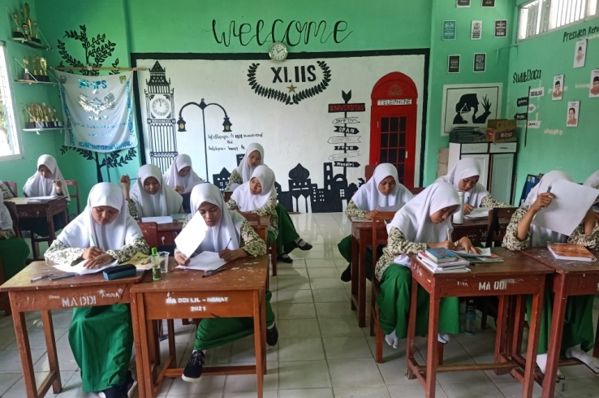

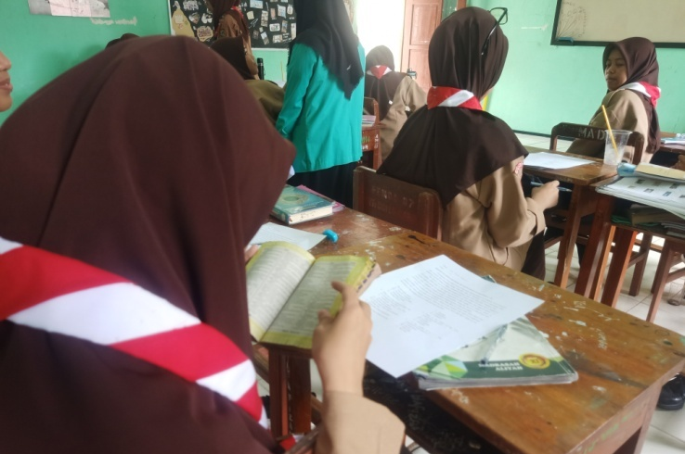

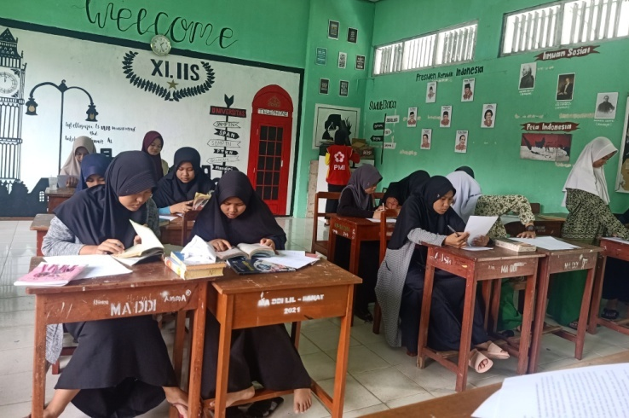

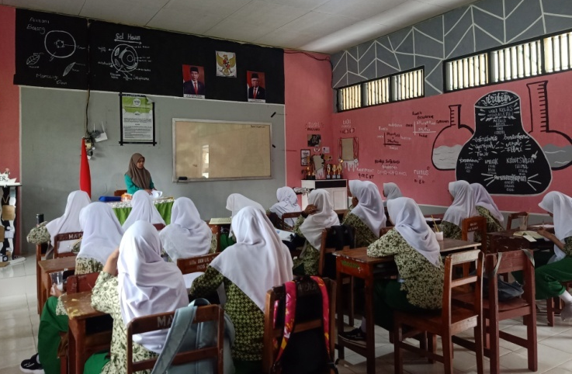

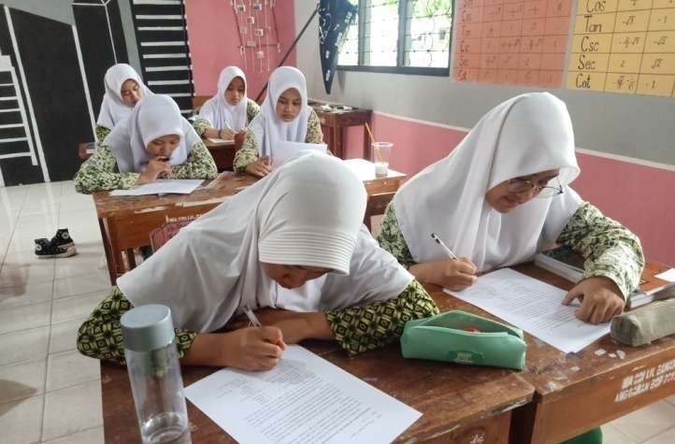
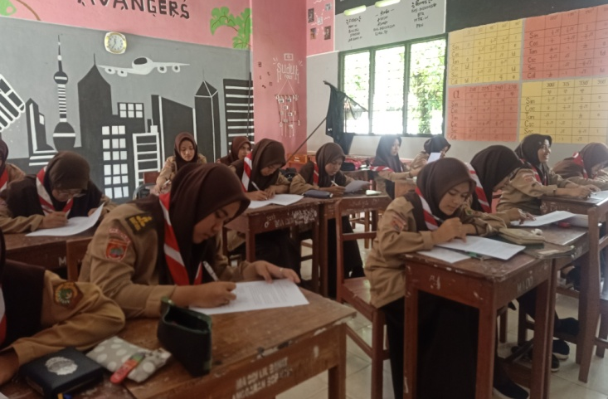
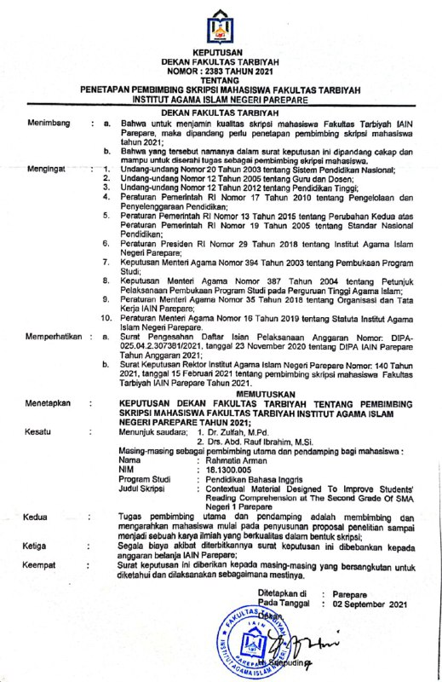
Appendix 7: Determination of student thesis supervisor

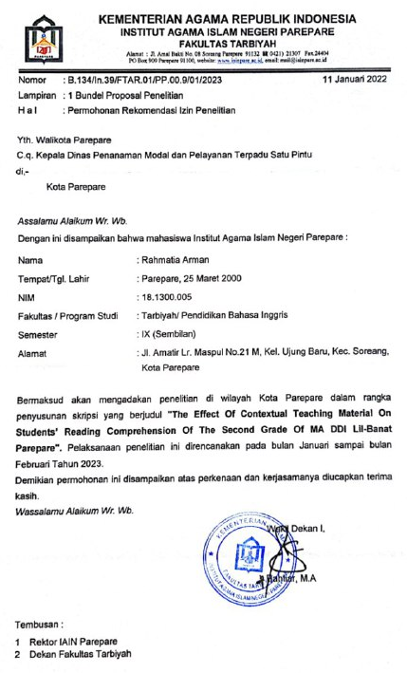
Appendix 8: Research permit recommendation

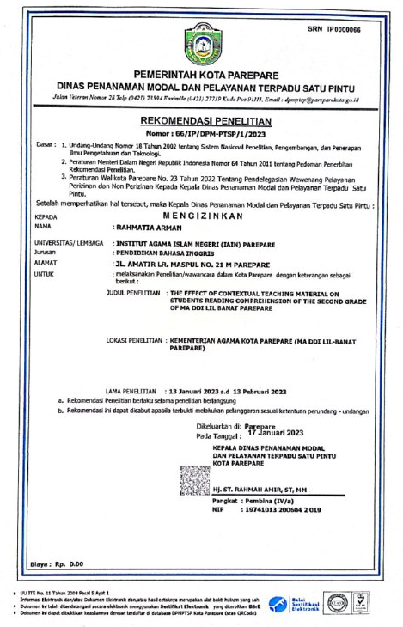
Appendix 9: Recommendation letter from Dinas Penanaman Modal dan Pelayanan Terpadu Satu Pintu

Appendix 10: Letter of research completing
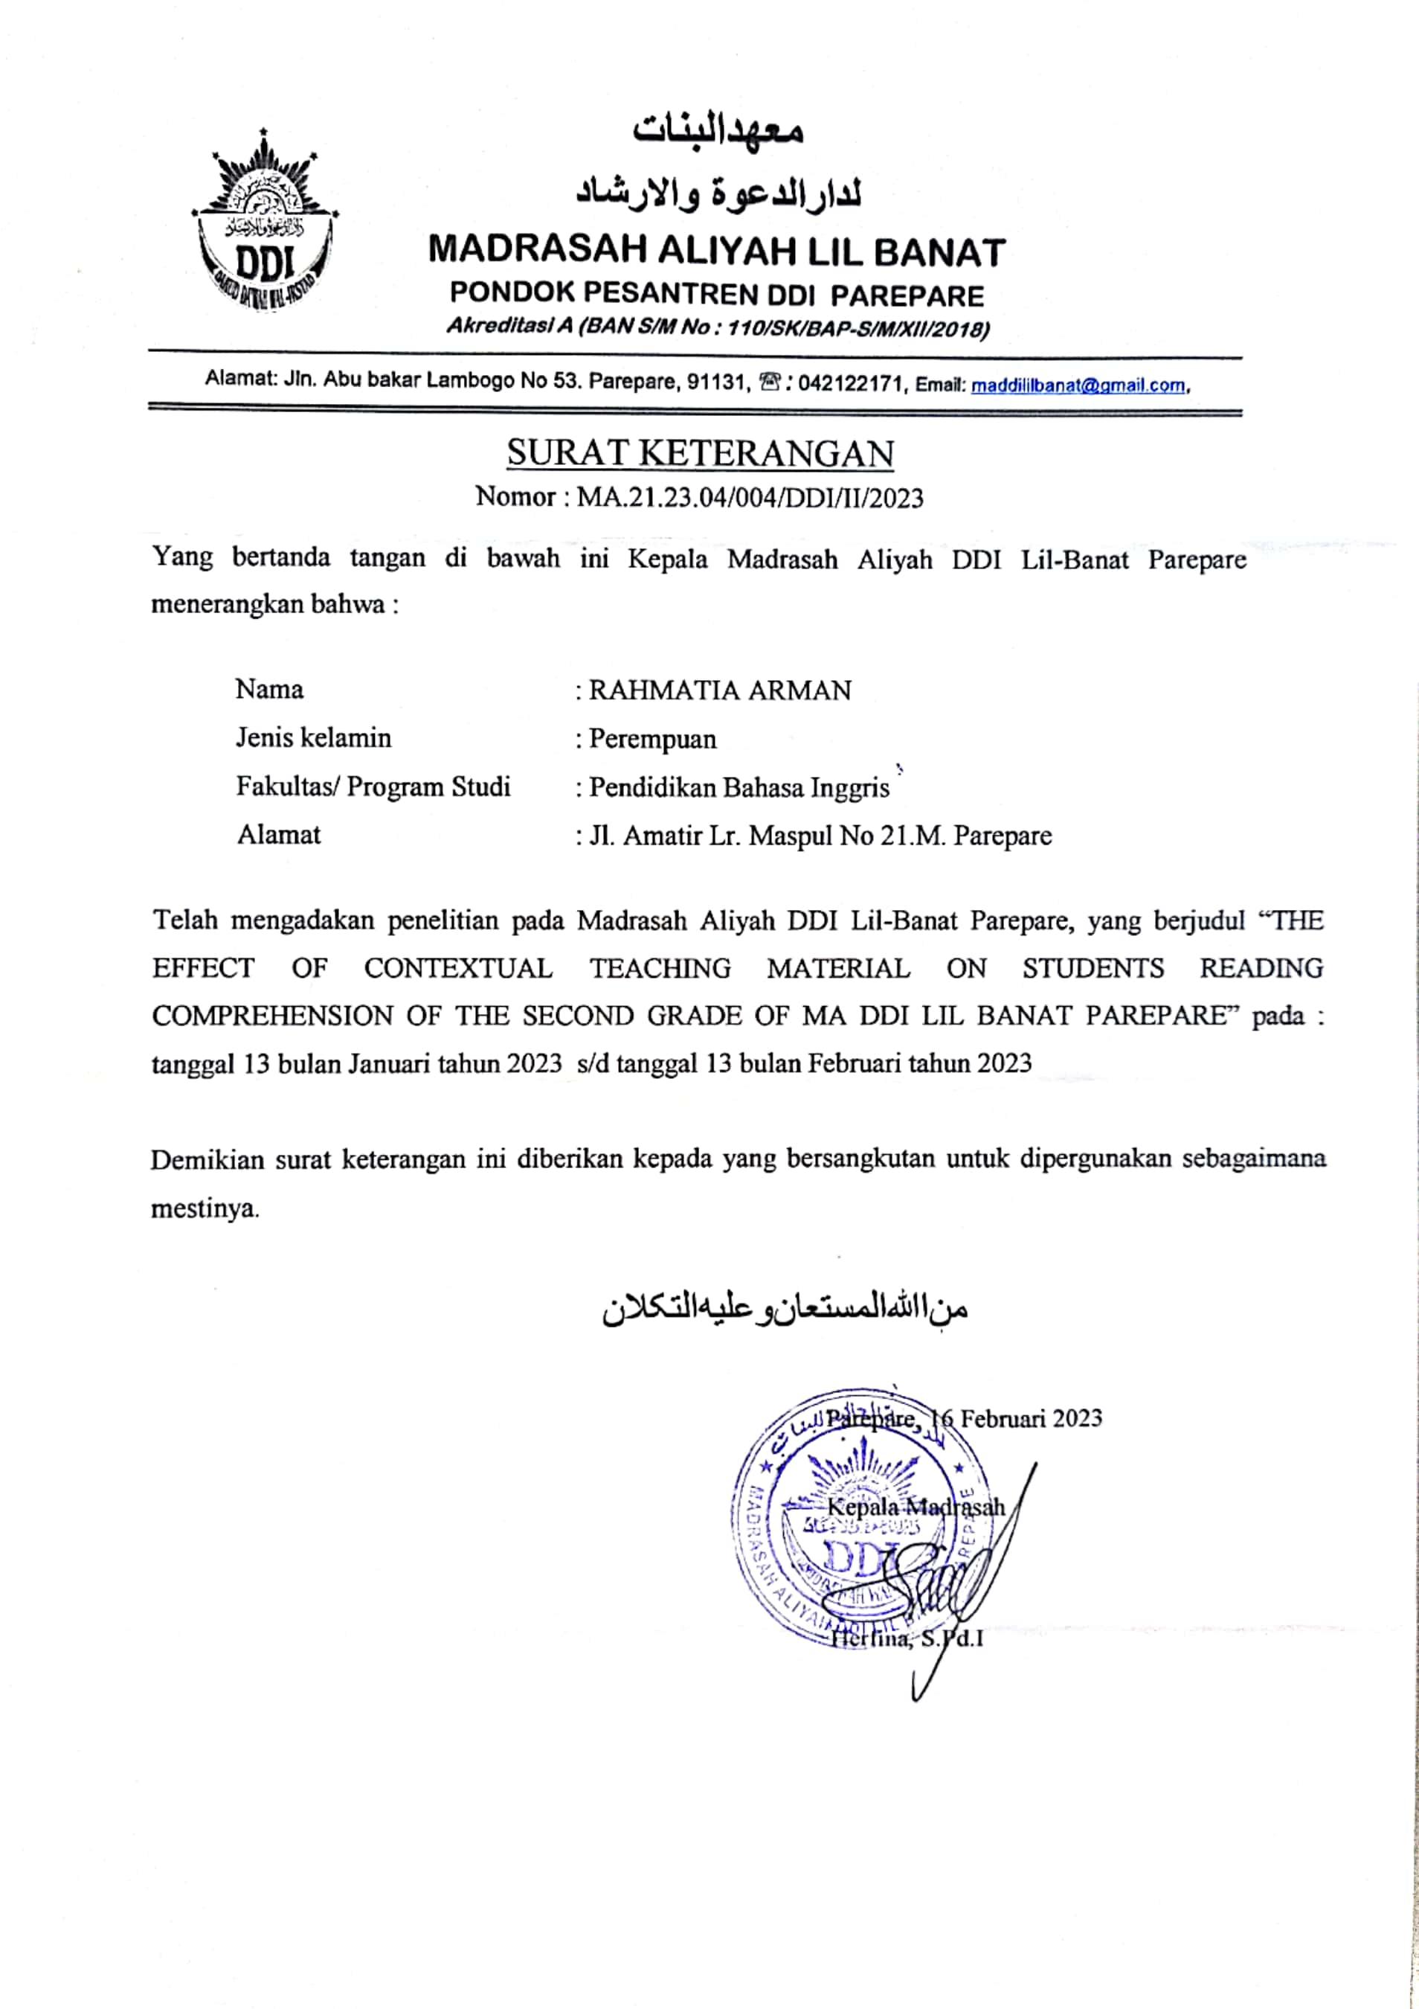

CURRICULUM VITAE
Rahmatia Arman, her short name is Tia. The writer was born on March 25th, 2000 in Parepare. She is the last child from six children in her family. From the couple of Arman. S and Rahmawati. Her education background, she began her study on 2006 in Elementary School at SDN 30 Parepare and graduated on 2012. She continued her study at SMPN 2 Parepare and graduated on 2015. She continued her study at SMAN 1 Parepare and graduated on 2018. Then, she continued her education at State Islamic Institute (IAIN) Parepare and took English Department of Tarbiyah Faculty as her major. Finally, on 2023 she completed her thesis with the tittle “The Effect of Contextual Teaching Material on Students’ Reading Comprehension of the Second Grade of MA DDI Lil-Banat Parepare”.

